The darling of the Internet era - POE network speaker
Date：2018-09-26 10:05:06
Today's network information is changing and developing at a high speed, which provides us with great convenience. People's demand for public broadcasting is also constantly demanding. Can we connect the existing analog passive speakers to the network and be the darling of the network era to make a SIP/IP network speaker, so that we no longer need too many complicated devices to work together? Broadcast paging or background music playback.
In the context of this demand, I looked for a number of companies, and by chance, at an exhibition, I saw a company called OBT that happened to have this product I was looking for for a long time. They showed me the various speakers. Function, access to LAN through RJ45, bandwidth up to 100MBPS, operation is very simple, no manual setting, network connection can automatically complete the connection with the server, support for the timing program from the server, local memory two ways, can automatically complete the timing program with the server Synchronization, when the server program changes, the automatic synchronization task after networking (is it very intelligent?) Support for receiving remote fixed-point broadcast, remote grouping and regional broadcasting (no need to go everywhere to set up), support cross-VLAN or Layer 3 routing is used.
In addition to the external 12V power adapter, this network speaker can also be powered by POE (PowerOverEthernet) (IEEE802.3af standard), so we don't need to pull another power cord out, and it reduces the safety hazard, and it is more beautiful. In this way, only one network cable connection is required for installation, and the construction is extremely simple, which greatly reduces the installation cost. The transmission protocol is a standard TCP/IP protocol. In addition, this speaker can also support the SIP protocol.
Full digital transmission, built-in high-speed industrial grade chip, 2*15W power amplifier motherboard and POE module, using embedded computer technology and DSP audio processing technology design, speaker unit full frequency band, high sensitivity, with abundant power, high fidelity CD-level sound quality.
Product appearance picture:

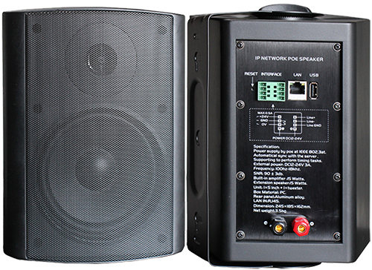
High-quality plastic speakers, exquisite and beautiful, craftsmanship, full of high-end temperament.
Just a friend needs this webcast product. I have recommended this intelligent broadcast product to my friends without hesitation, but the use scene is more suitable for white-speaker speakers. They found this company to ask if it can be customized into white. The company did not hesitate to agree to our request, really wants the customer's thoughts, the urgency of the customer, provides us with customized services, is a very good long-term cooperation supplier.

