SIP public broadcast multicast
Date：2018-09-26 09:48:07
Recently, SIP public broadcasting is very popular in the market. Is it the trend of public broadcasting development?
I used to see an IP public address system in the school that uses the TCP/IP network protocol to page and play background music. Each IP terminal is independent of each other, and each IP terminal is under LAN conditions. There is a separate IP address.
Suppose we need to page the IP public address system. I originally thought that it would be cumbersome to put multiple terminals in different classrooms and then page through each terminal as needed. Fortunately, I saw a manufacturer named OBT at the CEBIT show in Germany, and its SIP public broadcast successfully solved this doubt for me.

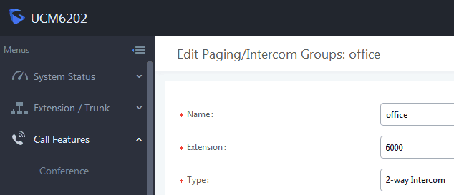

The specific steps are such as creating a new group, the group name is office, and then adding the required terminal to the group. When I need group paging, I only need to dial the group number, which is very convenient and simple to operate.

