New products at Hannover Fair - SIP Public Address System
Date：2018-09-26 10:18:27
At the invitation of a friend, I participated in the Hannover Fair as an audience in mid-June. Many new products left a deep impression on me. The one that impressed me the most was an exhibitor specializing in public broadcasting systems.
The company's registered brand is OBT, from Shenzhen, the main push SIP public broadcast and background music. Its products are composed of servers, SIPPOE ceiling speakers, SIPPOE wall-mounted speakers, SIPPOE outdoor waterproof sound column, SIP terminal controller, SIP network constant voltage amplifier, IPPBX and VoIP phones.
Secondly, the system connection is very simple, only need to connect to the POE router or switch through the ordinary RJ45 network cable, as shown in the figure below.
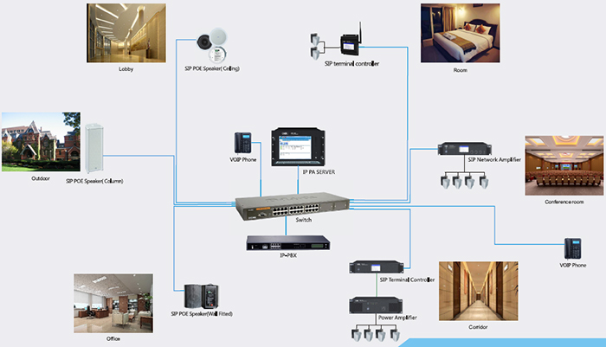
The role of SIP public broadcasting is mainly to play background music, use VoIP phones to page people, and you can also use VoIP phones for two-way intercom. It can be widely used in schools, shopping malls, hospitals, communities, and the like.
In addition, the system can be compatible with other security alarm systems. When a fire occurs, it can trigger an alarm and evacuate within the first time to ensure the safety of personnel and property.

