A small broadcasting system can also bring a lot of joy to children in poor mountainous areas.
Date：2018-09-26 10:23:46
Longyi Primary School is located in the west of Qiubei County, about 30 kilometers away from the county seat. It is located 14 kilometers northwest of the Eight Daoyun. It is next to the Qijiang Highway and is a national primary school in a remote mountainous area. In September 2008, the four schools (points) of Yuanlong, Xiaobuhong, Dazhuyu and Longjing Xinzhai were merged to form the current Longyan Primary School. The school has 14 teachers.
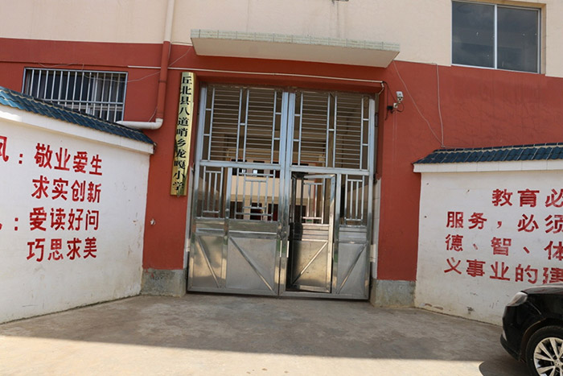
There are 509 households and 2,240 people in the district. The school has a total of seven classes including pre-school classes, 285 students, including 154 boarding students. Today, Longyan Primary School is a social praise, parents reassurance, student peace of mind, teacher satisfaction, all levels. Leaders value good schools of concern. Recently, with the stationing of campus radio, it has added a lot of joy to the children of this poor mountain school.
A month ago, Shenzhen Oubo Technology Co., Ltd. (OBT), a well-known public broadcasting manufacturer in Shenzhen, joined forces with Longyan Primary School to create a modern intelligent campus radio for Longyi Primary School. Now that one month has passed, the broadcasting system on the campus has all been installed and commissioned, and it is put into use as planned.
Don't look at a small campus broadcast, but it brought a lot of joy to the children of the school.
A month ago, the school still needed someone to guard the bell to ring the bell. Now, with the arrival of the OBT campus broadcast, only a simple setup is required. After the class is played, the bell is automatic, and it is still not differential. It’s time to ring the bell, which saves a lot of things for the school. A month ago, the school did the need to use the teacher's mouth to call the gymnastics. Usually, the teacher’s throat would be shouted by a broadcast, and the students behind could not hear it. Many students and teachers complained. Now, with the arrival of OBT campus radio, there will be no such problem. Not only can the entire school hear the sound of radio gymnastics, but even the whole village can hear it. The children are more energetic when they start broadcasting gymnastics. .
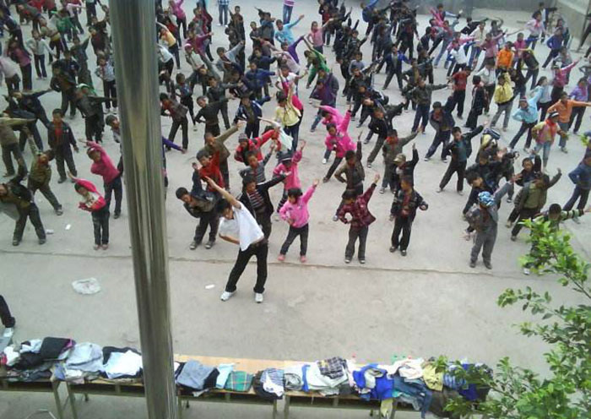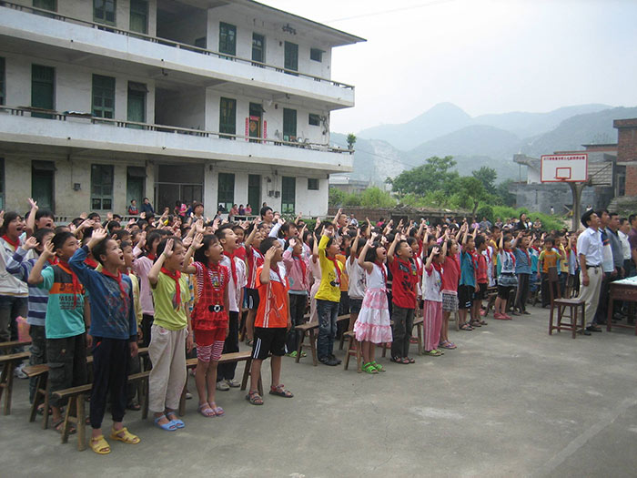
Now the children can not only do broadcast gymnastics, but also raise the national flag, do eye exercises, poetry reading games, and OBT campus broadcasting really brings a lot of fun to the children of Longyan Primary School.
Not only that, but OBT also installed a broadcast multimedia classroom for the school teachers, so that the teachers can also have more convenient time when they open the forum. The children can also hear the principal's speech without leaving the classroom. The principal has a task to issue. Don't even send text messages or phone calls to the teachers one by one. Campus radio really solves a lot of troubles for the school, greatly improves the teaching efficiency, and brings great convenience to the children's study and life. In addition to these features, the OBT Campus Radio has the following features:
1. Broadcast paging, the system can achieve point-to-point paging, packet paging and full-area paging;
2. Multi-source transmission at the same time, you can manually select the terminal server to play any audio source, or you can force the terminal server to play a certain audio source through the network host;
3. Independent broadcast (broadcast to the district)
4. Timed broadcast (unattended automatic broadcast) The music and area that need to be played at different times of the day can be programmed through the system, and the broadcast program can be set in advance to realize automatic broadcast all day, without special personnel, completely fully automated. control.
5. Telephone broadcast (telephone zone paging) The network broadcast system can be connected with the telephone input zone pager (or external line) to realize remote (or regional) telephone broadcast function, which can realize fixed-point broadcast, zone broadcast, and synchronization through telephone buttons. broadcast.
6. The alarm is strongly inserted into the broadcast all the way to force the strong plug, the external line alarm (such as fire alarm, etc.) once the alarm, can automatically trigger the entire system to start and access the alarm broadcast, no human operation;
7. Two-way intercom use remote call station can realize two-way intercom between host room and partition to achieve timely communication
OBT campus broadcasting is characterized by its advanced nature, stability, practicability, economy, compatibility and flexibility. It is an outstanding leader in modern campus broadcasting.
A bright tomorrow needs you and me – campus radio makes children's lives better. Long Hao Primary School gave a special thanks to the OBT brand!
