GUOSEN WOODWORKING MACHINERY MANUFACTUREING 大连国森木工机械制造有限公司
DALIAHsGUOSEN WOODWORKING MACHINERYMANUFACTUREING CO,LTD.

大连国森木工机械制造有限公司
DALIAN GUOSEN WOODWORKING MACHINERY MANUFACTUREING CO.,LTD.
ADD:DESHENG TOWN.ECONOMIC AND TECHNICAL DEVELOPMENT ZONE,DALIAN,CH I NA
Tel:400-0411-887
Fax:0411-8721 0992
Postcode:116635
Web:, www.guosenl996.com
CONTENTS
目录
企业介绍 一,
INTRODUCTION
精密单辐涂布机 ,
SINGLE ROGER COATER
精密双辐涂布机 —— ₍
DOUBLE ROLLER COATER
腻子机- —
FILLER MACHINE
双灯UV固化机
UV CURING MACHINE
三灯UV固化机
UV CURING MACHINE
热风干燥机…
AIR JET DRYER
3
GUOSEN
加热流平机-  LONGWARE IR LEVELING | -—19 | 均色毛刷机一  WIPING BRESH/STAINING BRUSH | —33
底漆砂光机 ——  PIRMER SANDER | …一21 | 除尘机  DUST CLEANING BRUSH MACHINE | 35
素板砂光机  HEAVY-DUTY SANDER | ——23 | 自动上料机  AUTOMACTIC FEEDER | ——……-37
上浮式砂光机  SANDER-HEAD ELEVATION (OVER-AND-UNDER) TYPE | -—25 | 输送机一----- -----  CONVEYOR | —39
BSA多功能毛刷机  BSA BRUSH SANDER | -—27 | 真空喷涂机  VACUUM SPRAYING MACHINE | 41
毛刺清除机…--…… ……  DEBURRING MACHINE | 29 | 旋转擦拭机 ……  POTARY DISK WIPE MACHINE | • -—43
仿古浮雕钢刷机  STEEL BRUSH MACHINE | ——31 | 合作客户 -…-  PARTNER | -45

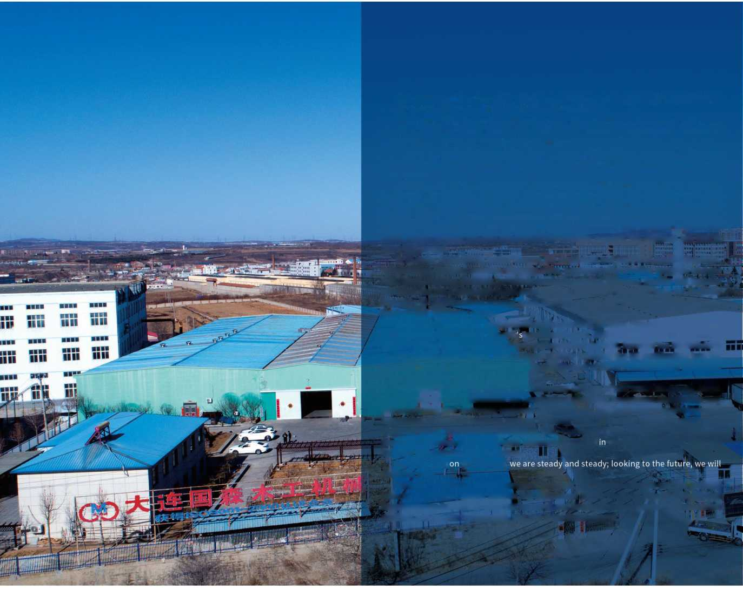
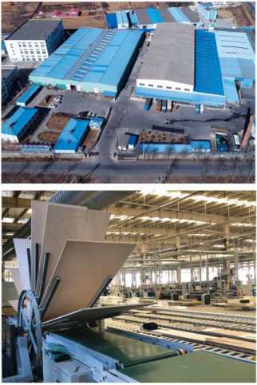
customer production lines and
the journey.
74 specifications of solid wood flooring, solid wood composite flooring, panel
craftsman spirit. Dalian Guosen has been actively promoting product standardization and standardization. In 2003, it passed the IS09001:2000 quality management system certification. In 2008, it passed the CE certification into the European market, which enhanced the competitiveness of China's woodworking machinery in the international market.
Dedicated to customer service and continuous creation of new value experience, Dalian Guosen can not only customize the production planning, equipment installation and commissioning and operation guidance for customers, but also provide customers with automated production upgrade services to create more in line with customer production characteristics. Professional production line. The world's first curved surface machine developed by Dalian Guosen has been successfully applied has been running smoothly for 2 years.
Looking back climb the peak.
With the continuous development of domestic and foreign markets and the growing scale of operations, Dalian Guosen has authorized Dalian Guofeng Electrical Appliance Manufacturing Co., Ltd. to carry out research and development upgrades for automation products and process technologies, and add a wonderful chapter.
There is a spirThere is a spirit called concentration, a quality called professional, a dream, is to make the world a more beautiful and convenient.
Founded in 1996, Dalian Guosen Woodworking Machinery Manufacturing Co., Ltd. covers an area of over 2,000 square meters. It is a professional company integrating R&D, production and sales of UV, PU and Fo-coating production lines.
Dalian, a beautiful coastal city, has given the efficient and convenient logistics environment of the sea, land and air, giving the spirit of Dalian Guosen a hundred rivers and forging ahead.
Since the day of its establishment, Dalian Guosen has been adhering to the business philosophy of ^{u}excellent technology, excellent product quality and excellent after-sales service". It is committed to the R&D and production of coating production lines, while focusing on the design and transformation of various mechanical industry automation. Customer-oriented, market-oriented, and constantly introduce new products to meet user needs, Dalian Guosen has won the trust of the majority of users, the products sell well at home and abroad.
In 23 years (1996-2019), Dalian Guosen has developed and produced sanding machine, reciprocating spraying machine, stacking dryer, precision roller coating machine, antique relief steel brushing machine, polishing machine, leveling machine, suction cup transfer machine, etc. 20 A complete set of paint surface coating production lines for multiple varieties, furniture and decorative panels.
Every detail can see the professionalism and creativity of Dalian Guosen. Every subtlety is the embodiment of Dalian Guosen
GUOSEN
COMPANY PROFILE
企业简介
国森，中国
PAGE 03/04
有一种精神叫专注，有一种品质叫专业，有一个梦想，是想让这个世界多一份美好和便捷。 大连国森木工机械制造有限公司成立于1996年，占地面积超2000平方米，是一家集研发、 生产、销售UV、PU及弗碳漆涂装生产线于一体的专业公司。
美丽的海滨城市大连，给予了海陆空高效便捷的物流环境，赋予了大连国森海纳百川、锐意 进取的精神气魄。
从创立那天起，大连国森一直秉承着“技术精尖、产品质量过硬、售后服务优质”的经营理 念，致力于涂装生产线的研发与生产，同时专注于各种机械工业自动化的设计改造。以客户为中 心，以市场为导向，不断推出适应用户需求的新产品，大连国森赢得了广大用户的信赖，产品畅 销国内外。23年间(1996-2019),大连国森已幵发生产砂光机、往复喷涂机、叠式干燥机、精密 辐涂机、仿古浮雕钢刷机、抛光机、流平机、吸盘移载机等20多个品种、74个规格的实木地板、 实木复合地板、板式家具及装饰板的油漆表面涂装生产线全套设备。
每一个细节，都能看到大连国森的专业性和创造性，每一个精微之处，都是大连国森工匠精 神的体现。大连国森不断积极推进产品规范化和标准化，2003年通过IS09001： 2000质量管理体 系认证，2008年通过进入欧洲市场的CE认证，提升了我国木工机械在国际市场的竞争力。
全心全意为客户服务，不断创造新的价值体验，大连国森不仅能针对客户特点进行私家定制 生产规划、设备安装调试及操作指导，还可以为客户提供自动化生产的升级服务，打造更符合客 户生产特点的专业生产线。大连国森研制的全球首例曲面机在客户生产线成功应用，已顺利运转 2年。
回望历程，我们踏实稳健；放眼未来，我们勇攀高峰。
随着国内外市场持续幵拓、经营规模不断壮大，大连国森已授权旗下大连国丰电器制造有限 公司，针对自动化产品及工艺技术进行研发升级，再添精彩华章。
PRODUCTORIENTED.COREOFCRAFT

以产品为导向.以工艺做核心
国森作为中国涂装行业的领军企业，成立二十三年来，为客户专属定制出1300 余条自动化涂装生产线，压缩生产成本，使客户能更高效、更便捷、更节约的完成 生产任务。
根据样板出具工艺测试报告，以更加合理、更加专业的角度，为客户配置专属 的自动化涂装生产方案。
样板工艺测试范围：平面、曲面、异形面

c®
GUOSEN
As the leading company in China's coating industry, Guosen has established more than 1,300 automated coating production lines for customers in the past 23 years, which has reduced the production cost and enabled customers to complete production tasks more efficiently, conveniently and more economically.
According to the sample production process test report, the customer will be assigned a dedicated automated coating production solution in a more reasonable and professional perspective.
Model process test range: plane, curved surface, profiled surface
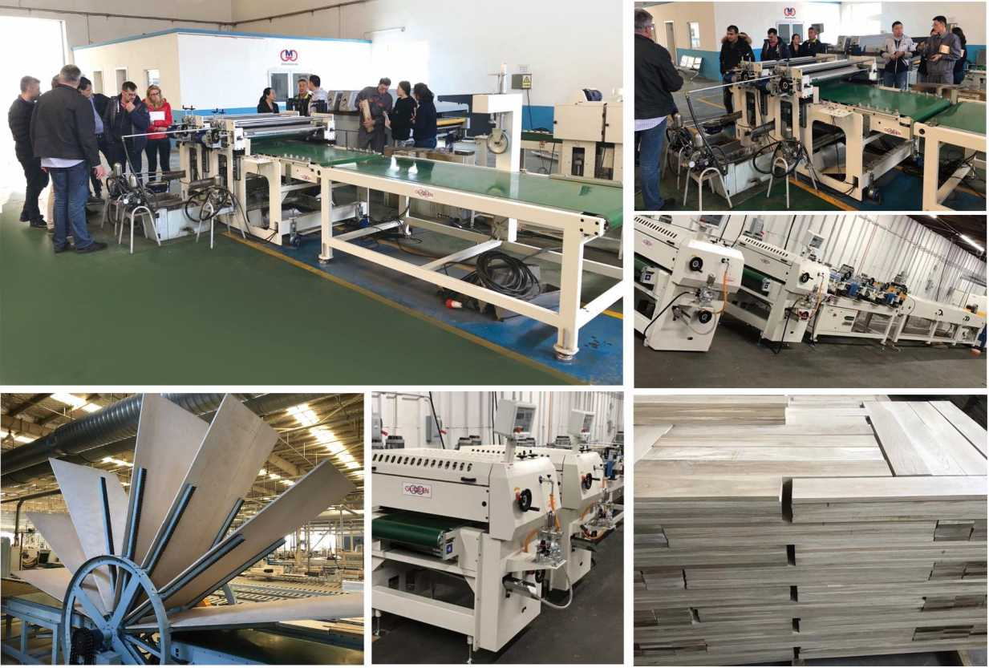
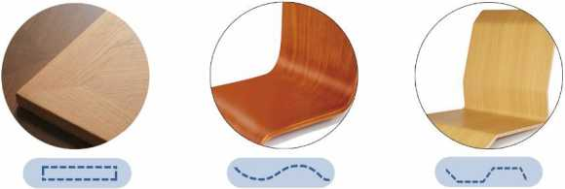

SINGLEROOERCOATER

精密单辐涂布机
GUOSEN
■本机专为平面板材表面涂漆而设计，由胶辐来涂布油漆，钢辐定量油 漆，油漆泵回收循环油漆；
■线速度3-18米/分钟，快拆式胶根，生产效率高；
■涂布量8-30g,可调节，漆膜薄而均匀，涂布效果好；
■进料调速、板面定厚、油漆加热，智能控制器，操作简单实用；
■钢辐胶辐可选配电机升降，胶辐紧急气动升起保护；
■联锁保护，三相五线制供电系统，操作安全。
- This machine is specially designed for painting the surface of flat plates. It
- is coated with paint by rubber roller, quantitative paint with steel roller, 口 and recycled paint for paint pump.
Line speed 3-18 m / min, quick release rubber roller, high production 口 efficiency;
口 The coating amount is 8-30g, which can be adjusted, the paint film is thin 口 and uniform, and the coating effect is good;
Feed speed regulation, plate thickness, paint heating, intelligent controller, simple and practical operation;
The steel roller rubber roller can be equipped with motor lifting and lifting, and the rubber roller is emergency pneumatic lifting protection; Interlock protection, three-phase five-wire power supply system, safe operation.
有效加工宽度：1300mm
有效加工厚度:3-80mm
最小加工长度:300mm
输送速度:18m/min
输送功率：0.75kw
涂布轮功率/尺寸:0.75kw/W50*1500mm
均布轮功率/尺寸:0.37kw/O175*1500mm
外形尺寸（L*W*H） :2000mm*2700mm*1700mm 重量：
Effective processing width: 1300mm
Effective processing thickness: 3-80mm
Minimum processing length: 300mm
Conveying speed: 18m/min
Transmission power: 0.75kw
Coating wheel power/ size: 0.75kw / 0250 * 1500mm Uniform wheel power / size: 0.37kw / 0175 * 1500mm Dimensions (L*W*H): 2000mm*2700mm*1700mm weight:
PAGE 07/08
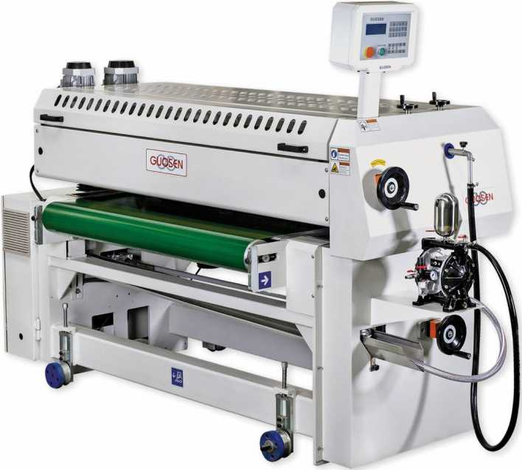
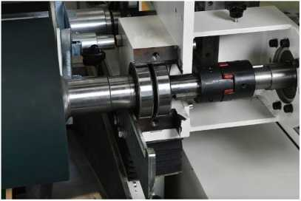
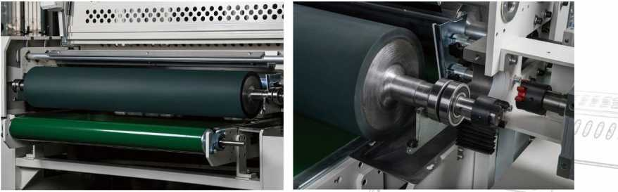
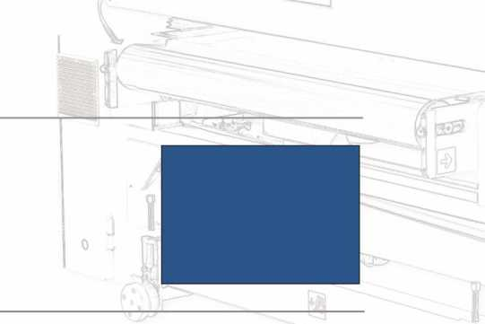

DOUBLEROLLERCOATER

精密双報涂布机
■本机专为平面板材表面涂漆而设计，由胶辐来涂布油漆，钢辐定量油漆，油漆泵回收循环油漆；
■线速度3-18米/分钟，快拆式胶辐，生产效率高；
- 涂布量8-30g,可调节，漆膜薄而均匀，涂布效果好；
- 进料调速、板面定厚、油漆加热，智能控制器，操作简单实用；
■钢辐胶辐可选配电机升降，胶辐紧急气动升起保护；
- 联锁保护，三相五线制供电系统，操作安全。
- This machine is specially designed for painting the surface of flat plates. It is coated with paint by rubber
- roller, quantitative paint with steel roller, and recycled paint for paint pump;
- Line speed 3-18 m / min, quick release rubber roller, high production efficiency;
- The coating amount is 8-30g, which can be adjusted, the paint film is thin and uniform, and the coating effect is good;
- Feed speed regulation, plate thickness, paint heating, intelligent controller, simple and practical operation;
- The steel roller rubber roller can be equipped with motor lifting and lifting, and the rubber roller is emergency pneumatic lifting protection;
GUOSEN
有效加工宽度：1300mm
有效加工厚度:3-80mm
最小加工长度:300mm
输送速度:18m/min
输送功率：0.75kw
涂布轮功率/尺寸：0.75kw/0250*1500mm
均布轮功率/尺寸:0.37kw/ei75*1500mm
外形尺寸（L*W*H） :2000mm*2700mm*1700mm 重量：
Effective processing width: 1300mm
Effective processing thickness: 3-80m'rn
Minimum processing length: 300mm
Conveying speed: 18m/min
Transmission power: 0.75kw
Coating wheel power/ size: 0.75kw / 0250 * 1500mm Uniform wheel power / size: 0.37kw / 0175 * 1500mm Dimensions (L*W*H): 2000mm*2700mm*1700mm weight:
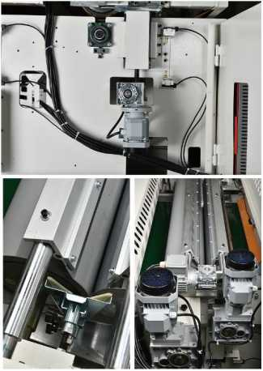
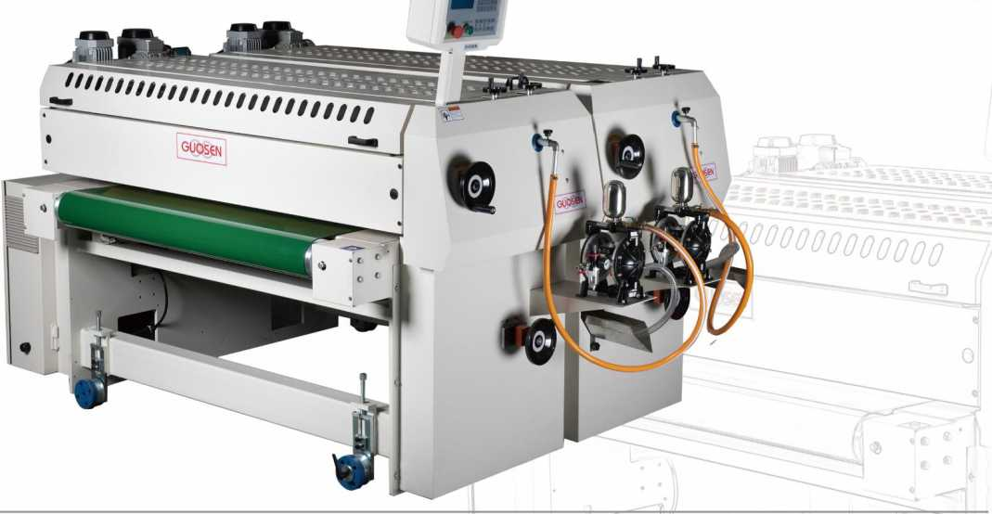

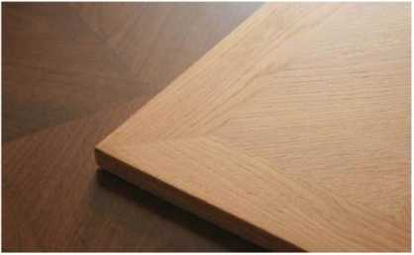
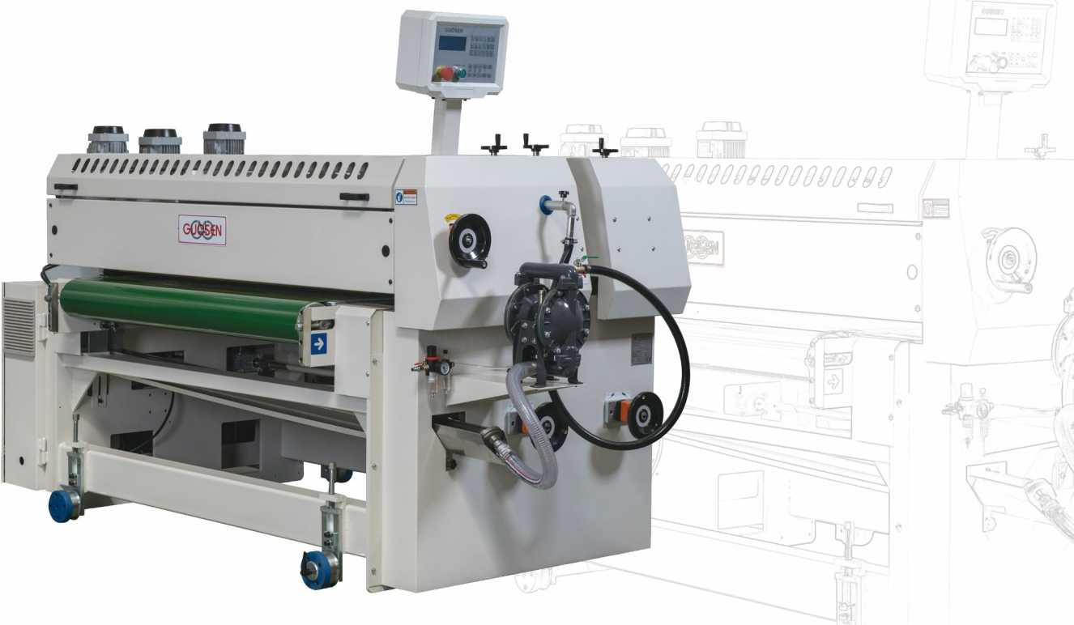
FILLER MACHINE
腻子机
GUOSEN
- 本机专为平面板材表面涂布uv腻子漆而设计，由胶辐来涂布腻子漆、钢辐定量腻子漆，一组钢辐逆向碾压腻子漆，油漆泵回收循环油漆;
- 线速度2-18米/分钟，快拆式胶辐，生产效率高；
- 涂布量8-30g,可调节，漆膜薄而均匀，涂布效果好；
- 进料调速、板面定厚、油漆加热、智能控制器、操作简单实用；
- 钢辐胶辐可选配电机升降，胶辐紧急启动升起保护，联锁保护，三相五线制供电系统，操作安全。
- This machine is specially designed for coating the surface of flat plate with UV putty paint. It is coated with putty paint, steel roller quantitative putty paint, a set of steel roller reverse crushing putty paint, and
- paint pump to recycle circulating paint;
- Line speed 2-18 m / min, quick release rubber roller, high production efficiency;
- The coating amount is 8-30g, which can be adjusted, the paint film is thin and uniform, and the coating
- effect is good;
Feed speed regulation, plate thickness, paint heating, intelligent controller, simple and practical operation;
The steel roller rubber roller can be equipped with motor lifting, rubber roller emergency start-up protection, interlock protection, three-phase five-wire power supply system, and safe operation.
UV CURING MACHINE

双灯uv固化机
GUOSEN
■ 本机专门uv漆的表面固化而设计;
UV干燥系统主要由四部分组成：UV光源、光电源控制装置、反射装置、冷却装置;
UV灯有全光半光两种工作模式，灯罩气动翻转，每只UV灯都配有独立灯罩、独立散
热风机，开关机后风机延时散热;
UV灯功率密度和峰值可按生产要求订做;
智能控制器自动记忆UV灯使用时间；人机数字显示屏可对进料调速、灯管全光与半
光切换，实现人性化操作;
联锁保护，三相五线制供电系统，操作安全。
This machine is specially designed to cure the surface of UV paint;
The UV drying system is mainly composed of four parts: a UV light source, a light power control device, a reflecting device, and a cooling device;
The UV lamp has two working modes: full-light and half-light. The lampshade is pneumatically flipped. Each UV lamp is equipped with a separate lampshade and an independent cooling fan. The fan after the switch is delayed in heat dissipation; UV lamp power density and peak value can be customized according to production requirements;
The intelligent controller automatically memorizes the use time of the UV lamp; the human-machine digital display can switch the feed speed control, the lamp full-light and the half-light to achieve humanized operation;
Interlock protection, three-phase five-wire power supply system, safe operation.
有效加工宽度：1300mm
有效加工厚度:3・80mm
最小加工长度：300mm
输送速度:18m/min
输送功率：0.4kw
风机功率:0.75kw
灯管功率：15kw （电子电源）*2
外形尺寸（L*W*H） :2083mm*2200mm*1600mm 重量：
Effective processing width: 1300mm
Effective processing thickness: 3-80mm
Minimum processing length: 300mm
Conveying speed: 18m/min
Transmission power: 0.4kw
Fan power: 0.75kw
Lamp power: 15kw (electronic power supply) * 2 Dimensions (L*W*H): 2083mm*2200mm*1600mm weight:
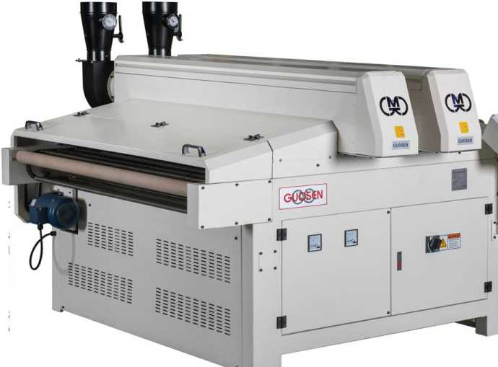
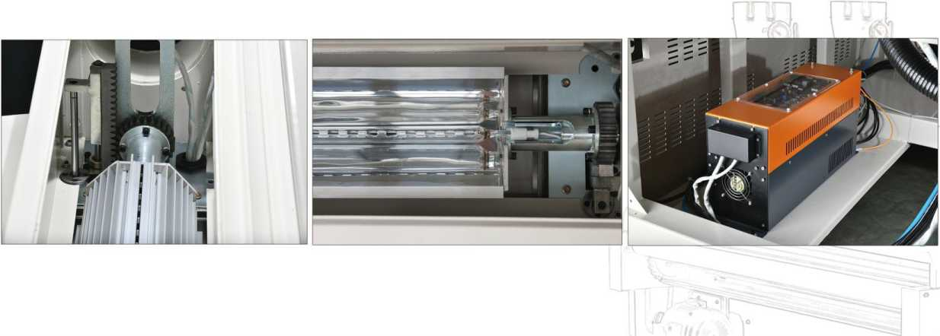
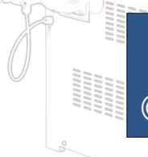
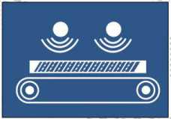

UV CURING MACHINE

三灯uv固化机
GUOSEN
■ 本机专门UV漆的表面固化而设计;
■ UV干燥系统主要由四部分组成：UV光源、光电源控制装置、反射装置、冷却装置;
UV灯有全光半光两种工作模式，灯罩气动翻转，每只UV灯都配有独立灯罩、独立
散热风机，开关机后风机延时散热;
UV灯功率密度和峰值可按生产要求订做;
智能控制器自动记忆UV灯使用时间；人机数字显示屏可对进料调速、
灯管全光与半光切换，实现人性化操作;
联锁保护，三相五线制供电系统，操作安全。
This machine is specially designed to cure the surface of UV paint; The UV drying system is mainly composed of four parts: a UV light light power control device, a reflecting device, and a cooling device; The UV lamp has two working modes: full-light and half-light. The lampshade
is pneumatically flipped. Each UV lamp is equipped with a separate lampshade and an independent cooling fan. The fan after the switch is delayed in heat dissipation;
UV lamp power density and peak value can be customized according to production requirements;
The intelligent controller automatically memorizes the use time of the UV lamp; the human-machine digital display can switch the feed speed control, the lamp full-light and the half-light to achieve humanized operation;
Interlock protection, three-phase five-wire power supply system, safe operation.
有效加工宽度：1300mm
有效加工厚度:3-80mm
最小加工长度：300mm
输送速度:18m/min
输送功率：0.4kw
风机功率：0.75kw
灯管功率:15kw （电子电源）*3
外形尺寸（L*W*H） :2083mm*2200mm*1600mm
重量：
Effective processing width: 1300mm
Effective processing thickness: 3-80mm
Minimum processing length: 300mm
Conveying speed: 18m/min
Transmission power: 0.4kw
Fan power: 0.75kw
Lamp power: 15kw (electronic power supply) * 2 Dimensions (L*W*H): 2083mm*2200mm*1600mm weight:
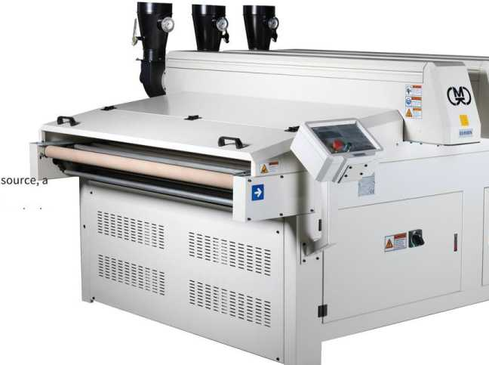
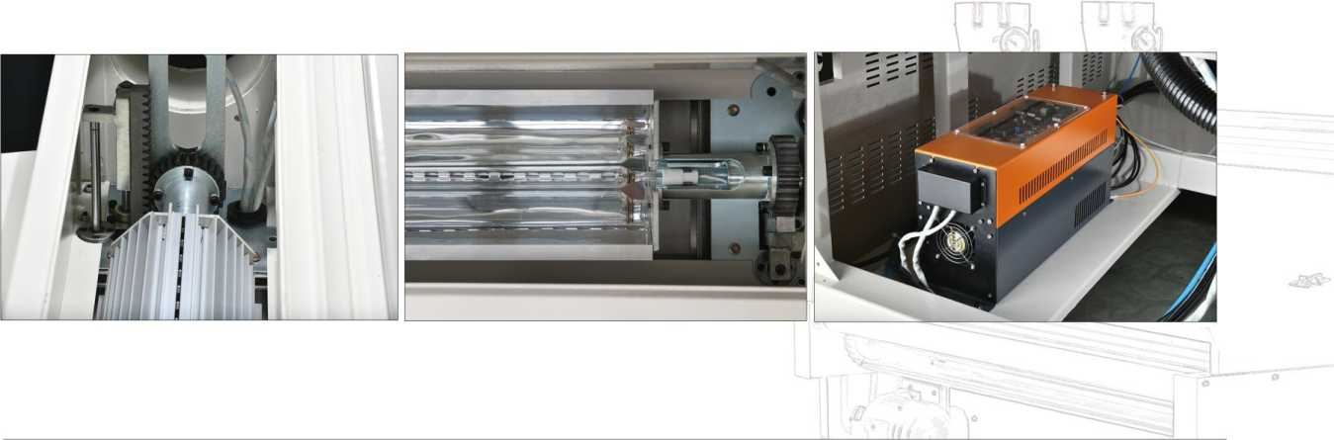
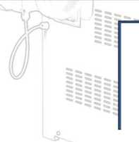
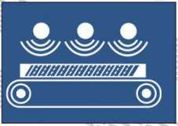

AIR JET DRYER

热风干燥机
GUOSEN
■红外线热风干燥机-GSGZ600A/GSGZ1300A
■板面着色漆的干燥设备；
- IR远红外加热、干燥、热风循环、排潮和输送于一体；
- 整机有升温快、温度可自动调节、节能省电等特点。
喷射式热风干燥机-GSGZ600B/GSGZ1300B
■板面着色漆的干燥设备；
- 喷射式风刀垂直送风，加热更均匀，节省空间，短波红外线灯
■穿透力更强干燥效果好；
- 可加配碳短波红外线灯、UV灯、蒸汽加热片等多种组合。
- Infrared hot airdryer-GSGZ600A/GSGZ1300A
- Drying equipmentfor board surface paint;
- IR far infrared heating, drying, hotaircirculation, moisture discharge
- and transportation;
The whole machine has the characteristics of fast heating,
- automatic temperature adjustment, energy saving and so on.
- Jet hot air dryer-GSGZ600B/GSGZ1300B
- Drying equipmentfor board surface paint;
- The jet type air knife feeds the air vertically, the heating is more uniform, and the space is saved. The short-wave infrared lamp has stronger penetrating power and good drying effect;
It can be equipped with various combinations of carbon short-wave infrared lamps, UV lamps, and steam heating sheets.
有效加工宽度:1300mm 有效加工厚度:3-80mm 最小加工长度：300mm 输送速度：18m/min 输送功率：
灯管功率：
外形尺寸（L*W*H）:
重量：
Effective processing width: 1300mm
Effective processing thickness: 3-80mm Minimum processing length: 300mm Conveying speed: 18m/min
Delivery power:
Lamp power:
Dimensions (L*W*H): weight:
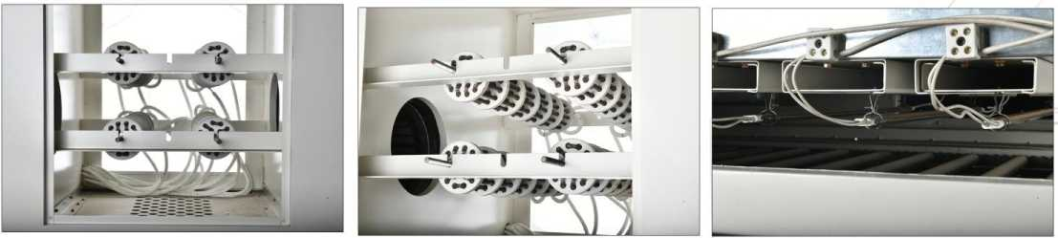
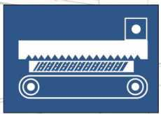

LONGWAREIR LEVELING

加热流平机
GUOSEN
■油漆表面加热设备，远红外均匀加热，使漆面效果更好。
□ Paint surface heating equipment, uniform heating in the far infrared, so that the paint surface effect is better.
有效加工宽度:1300mm 有效加工厚度:3-80mm 最小加工长度：300mm 输送速度:18m/min 输送功率：
灯管功率：
外形尺寸（L*W*H）: 重量：
Effective processing width: 1300mm
Effective processing thickness: 3-80mm Minimum processing length: 300mm Conveying speed: 18m/min
Delivery power:
Lamp power:
Dimensions (L*W*H): weight:
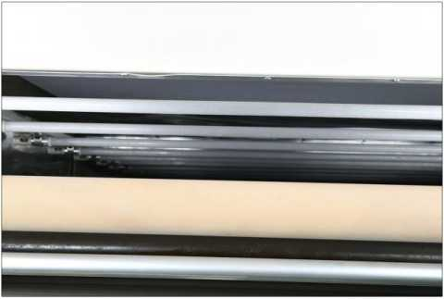
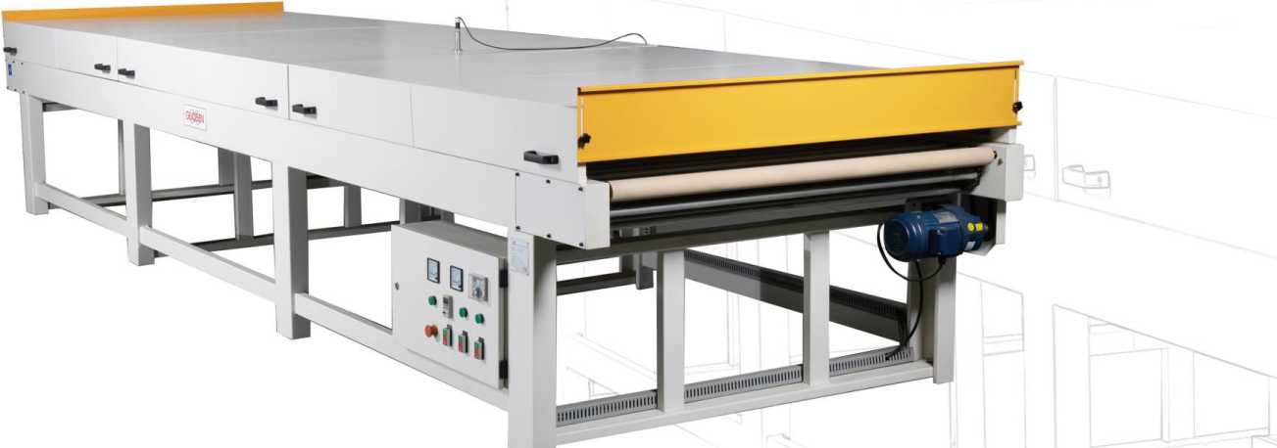
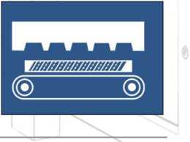

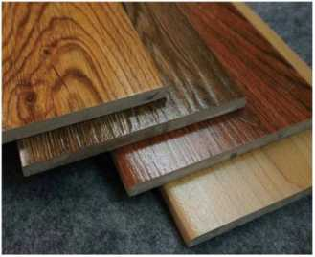
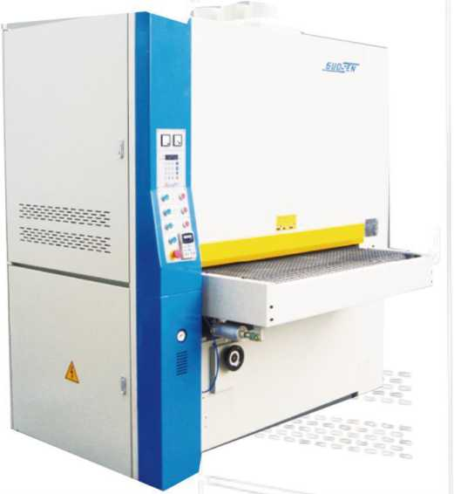
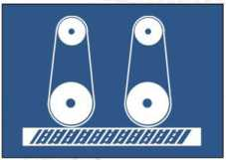
GUOSEN
有效加工宽度：1300mm
有效加工厚度:3-80mm 砂带尺寸：
功率：
外形尺寸（L*W*H）:
重量：
Effective processing width: 1300mm
Effective processing thickness: 3-80mm Belt size:
power:
Dimensions (L*W*H): weight:

PIRMER SANDER

底漆砂光机
- 底色研磨机械
- 通过电动驱动砂架研磨工件来完成，使工件漆面更加的平滑平整、厚度均匀一致，其表面光滑，达到工艺要求;
- 研磨材料有砂布、砂纸、百洁布、不织布、抛光轮等多种抛光方式可以选配和搭配使用。
- 对300mm以上原材料，压靴可利于砂带与工件接触面，利于砂光；
- 对各种规格的实木板或人造板贴木皮的工件都可进行砂光。
- Bottom color grinding machine
- It is completed by grinding the workpiece by electric driving sand frame, so that the paint surface of the workpiece is 口 smoother and flatter, the thickness is uniform and uniform, and the surface is smooth and meets the process
- requirements;
- Abrasive materials such as abrasive cloth, sandpaper, scouring pad, non-woven fabric, polishing wheel, etc. can be
- selected and matched.
For raw materials above 300mm, the pressure shoe can facilitate the contact between the abrasive belt and the workpiece, which is good for sanding;
Sanding can be performed on workpieces ofvarious specifications of solid wood or wood-based veneer.
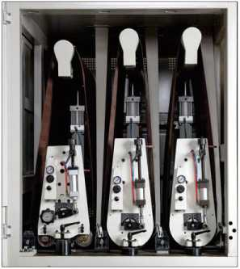
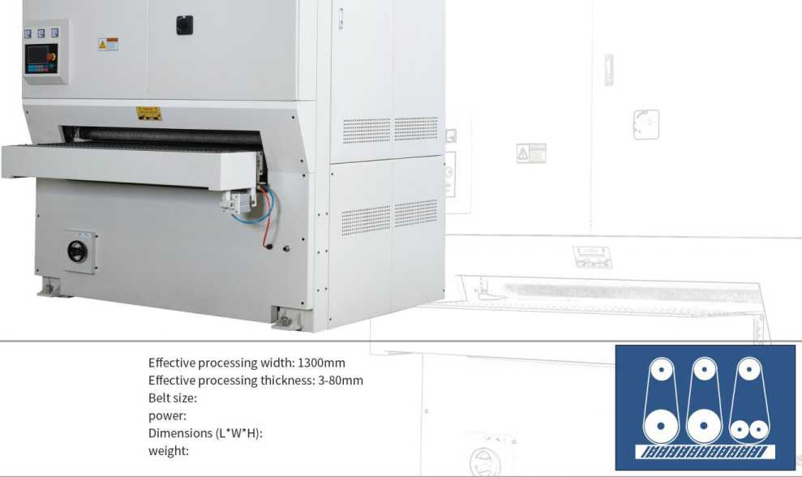
有效加工宽度：1300mm
有效加工厚度:3-80mm 砂带尺寸：
功率：
外形尺寸(L*W*H):
重量：

HEAVY・DUTYSANDER

素板砂光机
■平面定厚研磨的专用设备。由砂架、压辐、压靴及石墨垫等组合而成；
■通过高转速电机驱动砂架研磨辐来完成，使工件更加平整、厚度均匀一致，表面光滑，达到工艺要求;
■砂光辐动力十足，结实耐用。
- Special equipment for flat thickness grinding. It is made up of a combination of sand frame, pressure roller,
- pressure shoe and graphite pad；
The high-speed motor drives the sanding frame grinding roller to complete the workpiece, making the workpiece
- more flat, uniform in thickness and smooth in surface, meeting the process requirements;
The sanding roller is powerful and durable.
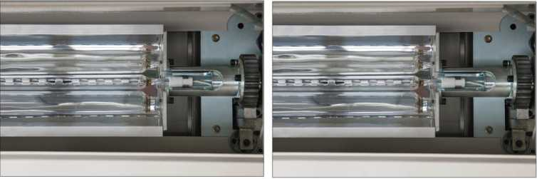
3
GUOSEN

SANDER・HEADELEVATION (OVER・AND・UNDER) TYPE

上浮式砂光机
- 1-工作件薄的和厚的都有，需要经常调整砂光厚度；
- 2-家具、门件组件、木皮。
- 1-The working piece is thin and thick, and the sanding thickness needs to be adjusted frequently;
- 2-furniture, door assembly, veneer.
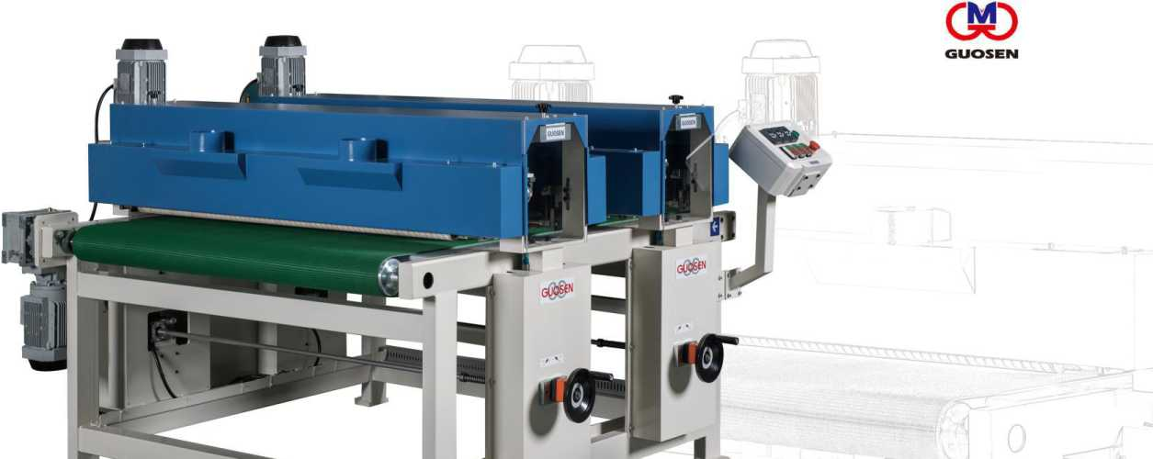
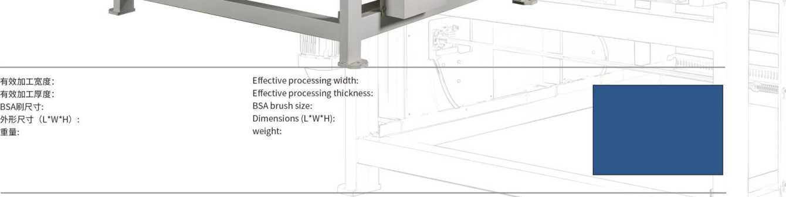
BSABRUSHSANDER
BSA多功能毛刷机
- BSA专用抛光设备，可处理异形、平面、曲面等多种工作件， 且油漆和素板均可使用，可配置成双面砂、单面砂、线条砂 等多种配置；
- 进口专用抛光刷效果俱佳，产品砂光效果稳定，纱布条和毛 刷可独立更换，更换方便，使用成本低。
- It can handle various workpieces such as special shapes, planes and curved surface used for both paintand plain plates. It can be combined according to the shape config workpiece;
- Imported special abandoning brush effect is good, the product sanding effect is stable cloth strip and the brush can be replaced independently, the replacement is conver use cost is low.
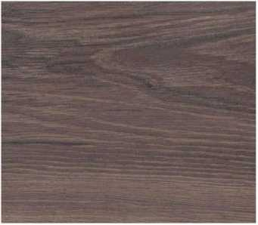
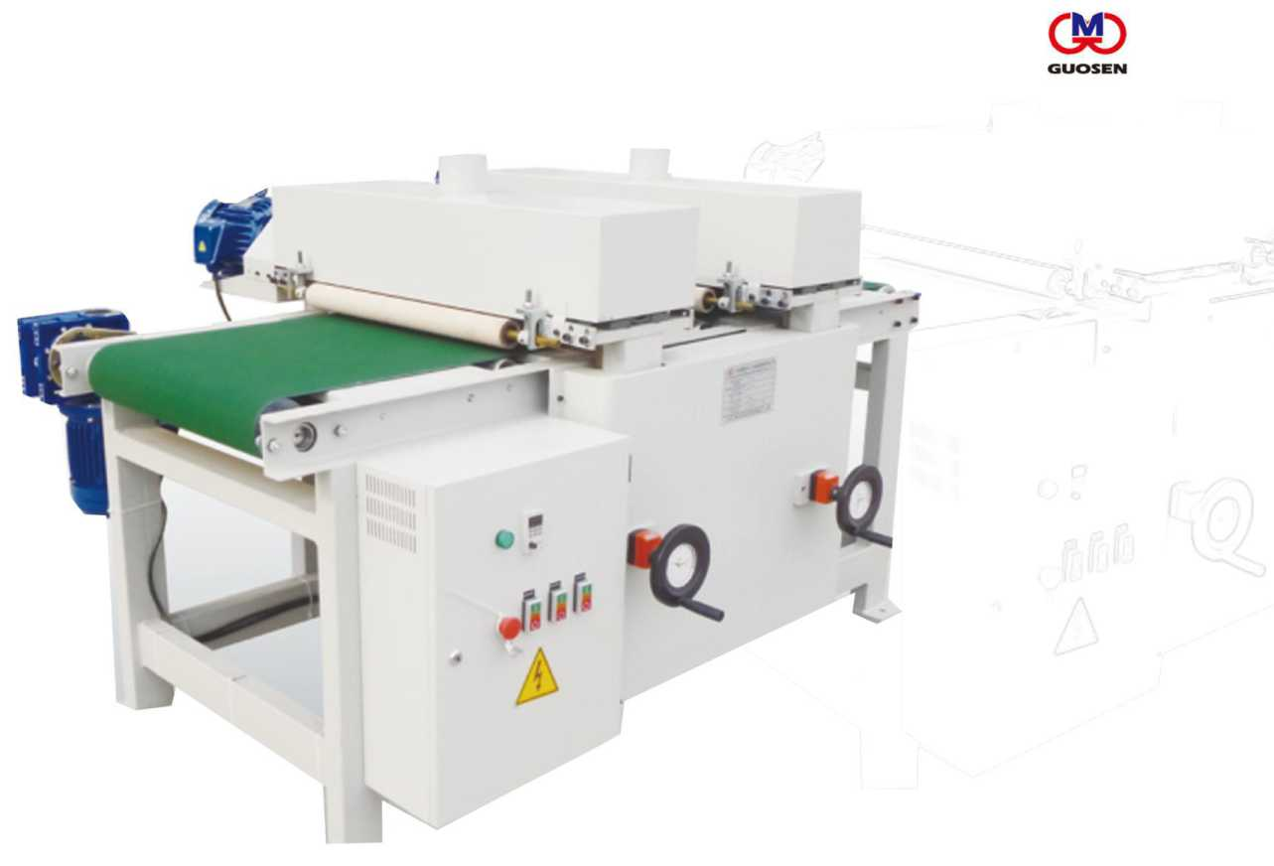
DEBURRING MACHINE
毛刺清除机
- 毛刺清除机是清除文理多余木纤维，使水性着色底漆着色效果提升的专用设备。
- 采用进口高材质合金磨料丝（杜邦丝）刷，对水性着色毛刺进行打磨能有效的消除毛刺或着 色点，效果俱佳。
- The burr remover is a special equipment for removing the excess wood fiber from the culture and improving the coloring effect of the water-based coloring primer.
- The imported high-alloy alloy abrasive wire (DuPont) brush can effectively remove burrs or colored spots by polishing the water-based colored burrs.

STEEL BRUSH MACHINE

仿古浮雕钢刷机
GUOSEN

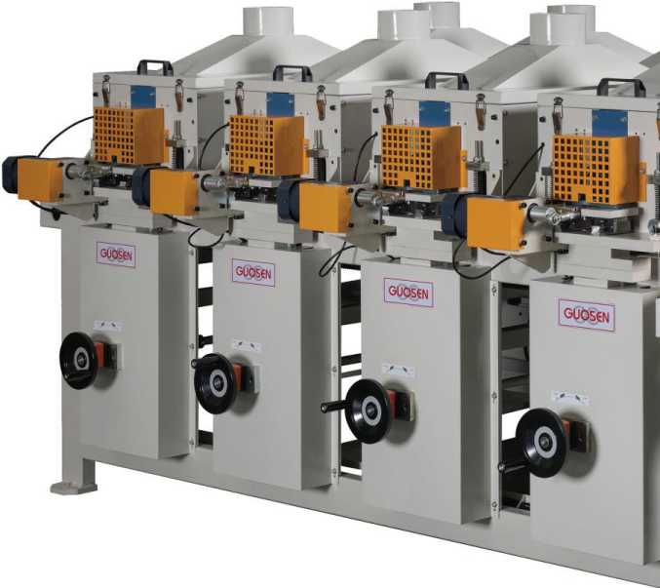
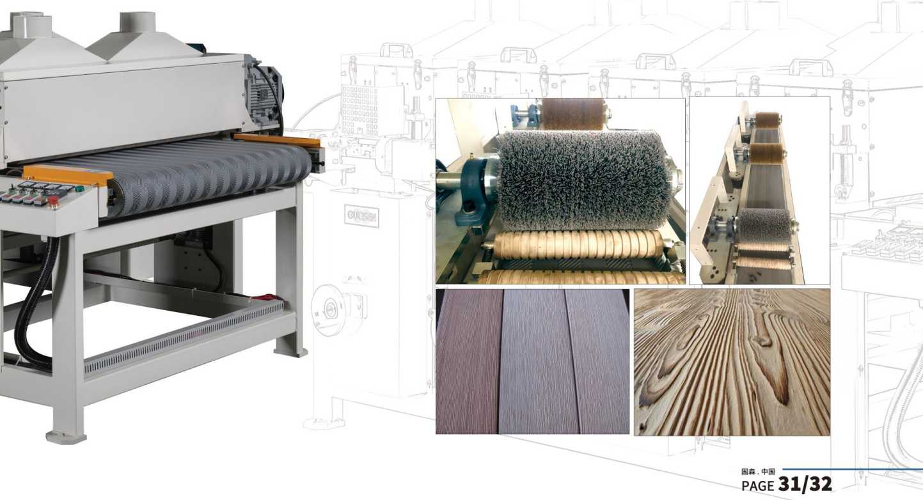
- 刚刷机是加工仿古拉丝板的专用设备。
- 采用进口高材质、高精度的机床专用滑道，使整机运转平稳、振动力小；
- 板材厚薄采用无间隙燕尾槽铸件升降控制，稳定而精确；
. 刷辐采用横向往复运动，加工出的文理更美观、清晰、立体；
- 刷馄可选配的材质有：钢丝、合金磨料丝(杜邦丝)、砂布轮、3M抛光轮。
- The brush machine is a special equipment for processing antique wire drawing
- boards.
The imported high-quality, high-precision machine-specific slides make the
- machine run smoothly and the vibration force is small;
The thickness ofthe plate is controlled by the lifting and lowering ofthe dovetail
- groove casting without gaps, which is stable and precise;
The brush roller adopts lateral reciprocating motion, and the processed arts and
- crafts are more beautiful, clear and three-dimensional;
The optional materials for the brush roller are: steel wire, alloy abrasive wire (DuPont wire), abrasive cloth wheel, 3M polishing wheel.

WIPING BRESH/STAINING BRUSH

均色毛刷机
- 板面均色专用设备。
- 适用于板式家具、平面门、橱柜侧板、实木复合地板、工艺
品、竹木窗帘等平面工件进行水性着色后擦拭均匀
- Special equipment for board surface color.
- Suitable for flat furniture such as panel furniture, plane doors, cabinet side panels, solid wood composite flooring, handicrafts, bamboo curtains, etc.
有效加工宽度:1300mm
有效加工厚度:3-80mm
最小加工长度：300mm
输送速度:18m/min 毛刷尺寸：
Effective processing width: 1300mm
Effective processing thickness: 3-80mm
Minimum processing length: 300mm
Conveying speed： 18m/min
Brush size:
Dimensions (L*W*H):
Wei
ght:
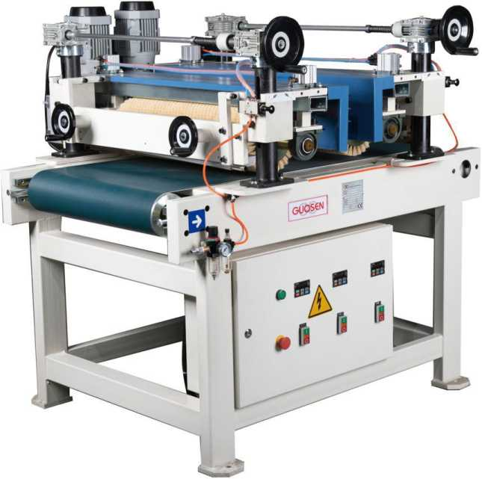
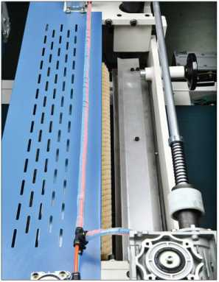
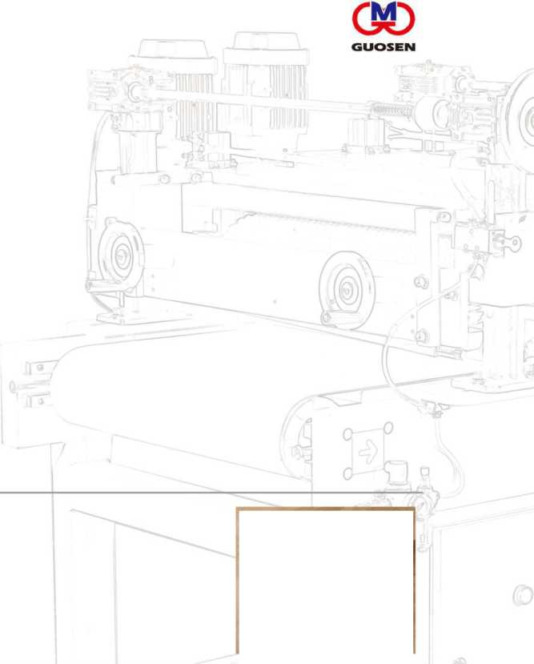
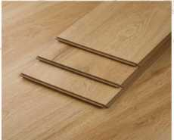

DUSTCLEANINGBRUSHMACHINE

除尘机
■清除素板或油漆砂光板面粉尘的专用设备。
■植物性毛刷抗静电，配有强力吸尘风机，除尘效果更彻底。
■除尘毛刷材质可选配不同材质。
- Special equipment for removing fine dust from plain boards or paint sanding boards.
- The plant hair brush is anti-static and equipped with a powerful dust suction fan. The dust
- removal effect is more thorough.
Dust brush material can be selected with different materials.
有效加工宽度:1300mm
有效加工厚度:3-80mm
最小加工长度：300mm
输送速度:2-80mm
毛刷尺寸：4)150*1310mm
外形尺寸(L*W*H) :2000mm*1700mm*1800mm 重量：
Effective processing width: 1300mm
Effective processing thickness: 3-80mm
Minimum processing length: 300mm
Conveying speed: 2-80mm
Brush size:(|)150*1310mm
Dimensions (L*W*H): 2000mm*1700mm*1800mm weight:
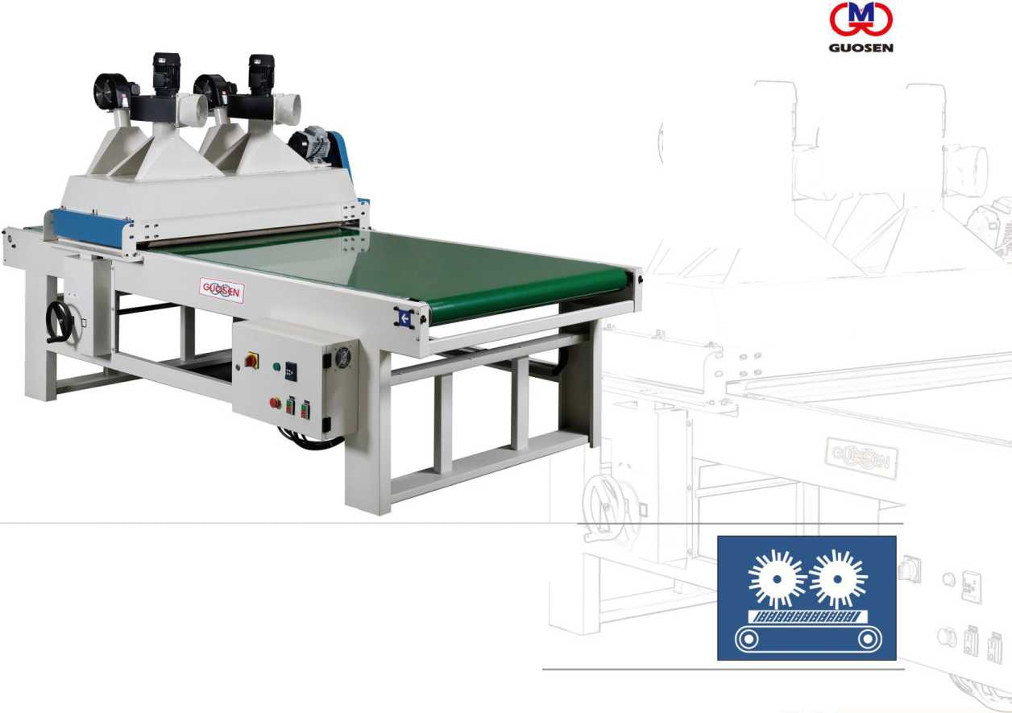
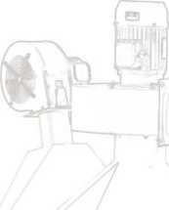
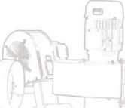

AUTOMATIC FEEDER

自动上料机
GUOSEN

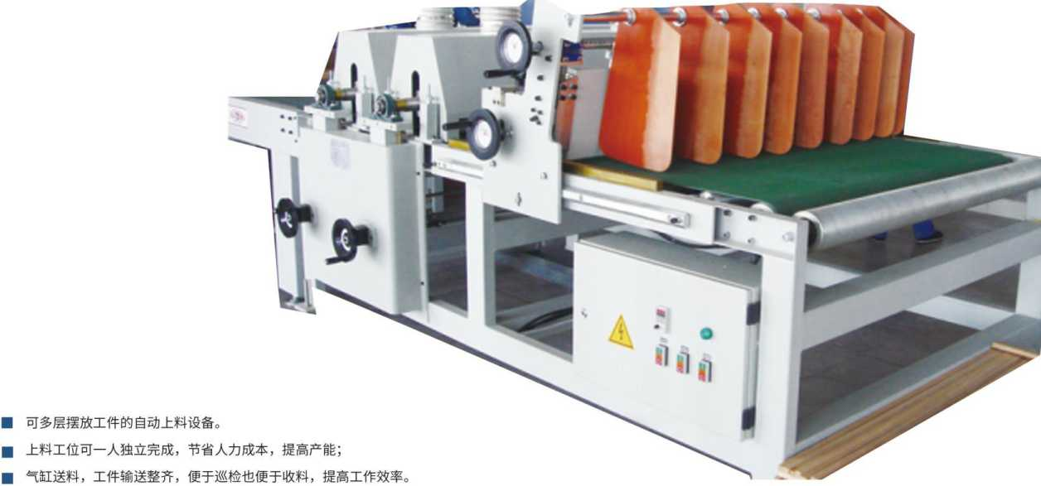
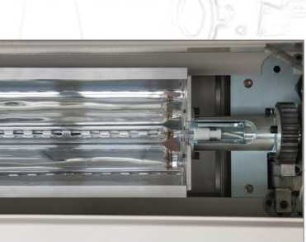
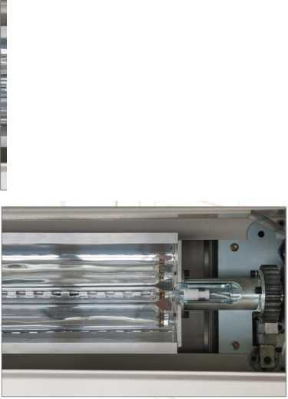
- Automatic loading device for multi-layer workpiece placement.
- The loading station can be completed by one person independently, saving labor costs and increasing production capacity;
- The cylinder feeds the workpiece, and the workpiece is neatly conveyed, which is convenient for inspection and easy to receive materials, and improves work efficiency.

CONVEYOR

输送机
GUOSEN

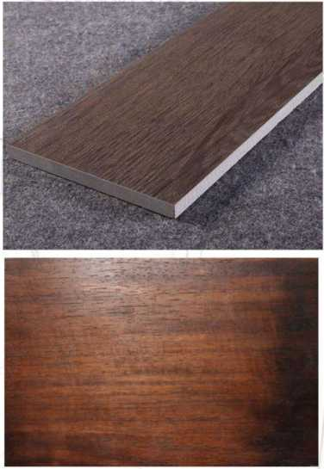
- Paint line conveying equipment.
- It is divided into belt type and roller type from the transmission mode;
- From the station is divided into fixed and mobile;
- From the shape of the general conveyor, 90 degree right angle turning machine, U-turn conveyor.
■漆线输送设备。
■从传动方式上分为皮带式和辐筒式；
■从工位上分为固定式和移动式；
■ 从形状上分为普通输送机、90度直角转弯机、U型转弯输送机。

VACUUMSPRAYINGMACHINE

真空喷涂机
口 口口口
采用国际领先的真空喷涂技术，结合国内外真空喷涂机的特点，研发销售的新型木工机械设备。 适合任何横截面的条形工件的喷漆；
可实现工件四面一次性喷涂；
适用于UV漆、水性漆、植物油等液态涂料；
涂膜厚度科变频调整，喷涂过程全程在箱体内，涂料100%回收利用，清洁环保。
The company adopts international leading vacuum spraying technology and combines the characteristics of vacuum spraying machines at home and abroad to develop and sell new woodworking machinery and equipment.
Suitable for painting of strip workpieces of any cross section;
It can realize one-time spraying on all sides of the workpiece;
Suitable for liquid paints such as UV paint, water-based paint and vegetable oil;
The coating film thickness is adjusted by frequency conversion. The whole process of spraying is in the box body, and the paint is 100% recycled, which is clean and environmentally friendly.
有效加工宽度：
有效加工厚度：
外形尺寸（L*W*H）:
重量：
Effective processing width:
Effective processing thickness:
Dimensions (L*W*H): weight:
GUOSEN
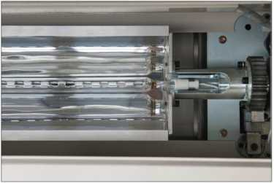

POTARY DISK WIPE MACHINE

旋转擦拭机
(M)
GUOSEN
■ UV漆、水性漆、植物油和木蜡油
□ Professional wiping water paint,UV oil and Natural Plant oil.
有效加工宽度:1300mm 有效加工厚度:3-80mm 最小加工长度：300mm 输送速度：18m/min 输送功率：
毛刷尺寸：
擦拭盘尺寸：
外形尺寸(L*W*H): 重量：
Effective processing width: 1300mm
Effective processing thickness: 3-80mm
Minimum processing length: 300mm
Conveying speed: 18m/min
Delivery power:
Brush size:
Wipe disc size:
Dimensions (L*W*H):
weight:
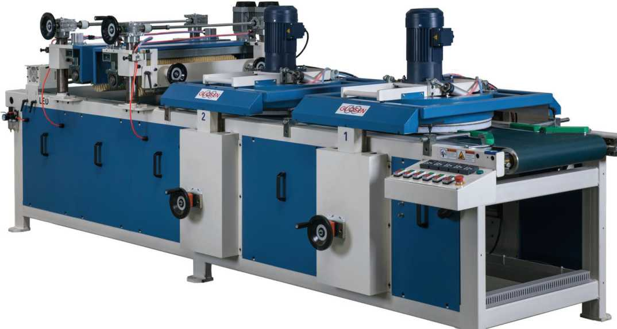
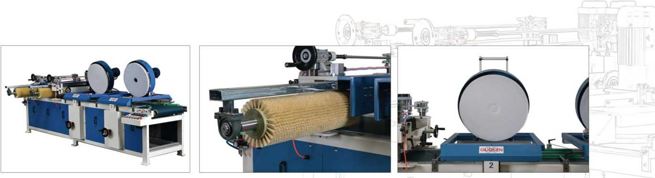
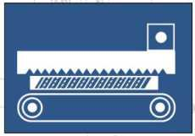

PARTNER
合作客户
创rstnong兩尔血板
Der Huili 0 士比 mtmt梦天木门
DASSO 人在 » I ： •好多•好生活
金 drewesin 書 u
任 E/XGON
Lamett乐迈
PT Katwara
SERFlEksl
UKWoodFloors
Old world
具 .h X
KLUMPP
・・••■■ ■■■■I
AkzoNobel
IbmorrowfeAnswersTodav
SUN龄 RD
WlN&WNW0(® |  |  |  |  | i 1 | OREGON =LUMBER CO.= «alW

Bona
Passion for wood floors
G
GIBBS • SAN DTECH
(Xbroodk'of
beautiful real wood
Boloni
科宝-博洛尼
PetnalisiSi
Orosimn
-www.DJsmm.com
大连嘉宏木业有限公司
HARDWOOD
赛强感地板
tati SVENS
M球家地板
GREEN HOME
贝尔地板，一
福马
■INDUSTRY
valspar
梦天木门
■ SKIt.MVX*n
空^展鴻木业
ZHAN NONO MU YB
亨
DuChateau*
MSBS
LAND
OSL.G
FLOORING
南寶樹脂
Galleher
JL
^^AXIPlywood
More than just Plywood
ey\hc 制門
Of AU f TV DOCifWt
VShiLin 口曰 l
菲林格尔
BIYORI\
贝亚克地板
•••
蓝反木il窗
«»*n ttWBB
理春兴家地板有服羨任公司
cxhcxingiiaaiban.cam.pelGB.com
