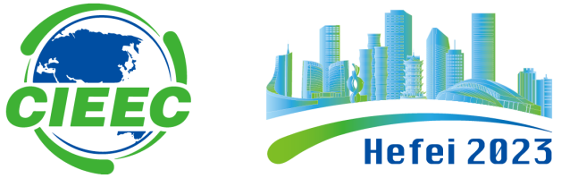

2023 IEEE第六届国际电气与能源大会
2023 IEEE 6th International Electrical and Energy Conference
（CIEEC 2023）
Hefei, China / 中国，合肥
May. 12-14 ,2023 / 2023年5月12-14日

Call for Tutorial Proposals

Tutorial Proposal Submissions
2023 IEEE 6th International Electrical and Energy Conference（CIEEC 2023）solicits proposals for 3 hours Tutorials that complement the regular program with clear and focused coverage in new and emerging topics within the scope of conference. Tutorials are an opportunity for researchers, developers and practitioners from academia and industry to learn about the state-of-the-art research.

How to Submit Tutorial proposal
- Tutorial proposals should be submitted by the prospective Tutorial Speaker (s).
- Tutorial Length: 3 hrs
- All Proposals will be peer reviewed.
- Each proposal must fill in the following form and send to cieec@vip.163.com

Important dates for Tutorial proposal submissions
- Tutorial proposal submissions: Mar. 25, 2023
- Proposal acceptance notification: Apr. 10, 2023
- Tutorial Date: 14:00-17:00, May 12, 2023

Tutorial Proposal Form
Tutorial Speaker Name |  | Photo of Tutorial Speaker
Email
Cell Phone
Affiliate & Title
Title of Tutorial

Description of the Tutorial Proposal | - Objectives and motivation  - Novelty, highlighting the technical innovations presented in this tutorial  - Tutorial content, indicating the topics that the tutorial will cover in detail
Abstract
Bio(200 words)

