九州期货个人居间公示信息
居间姓名 | 居间证件号 | 到期日 | 居间编号 | 照片
祝洪涛 | 13063519****010092 | 20240323 | J0004436
胡志顺 | 36242519****141810 | 20240327 | J0010169
肖翠兰 | 51372319****149186 | 20240411 | J0008241
南章永 | 41152419****074713 | 20240412 | J0004017
胡燕霞 | 13042519****134240 | 20240605 | J0003591
李康 | 42010619****030415 | 20240626 | J0006221
魏丹 | 42010219****152815 | 20240626 | J0005312 | 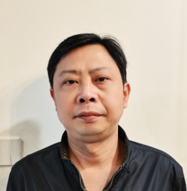
邓叶 | 43058119****050524 | 20240725 | J0010772
胡宏华 | 51028319****104656 | 20240815 | J0010872
卫军虎 | 14043119****236413 | 20240908 | J0006748
雷雨倩 | 61250119****060226 | 20240908 | J0008501 | 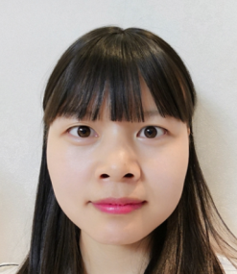
赵莹莉 | 41142519****030669 | 20240917 | J0008961 | 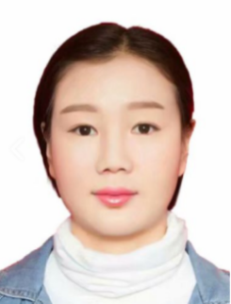
郝欣 | 23022119****151229 | 20241022 | J0009145
卿永光 | 43072219****273072 | 20241019 | J0009163
宋欣 | 15252419****010645 | 20241019 | J0011111
罗绫 | 44142119****151148 | 20241030 | J0011162 | 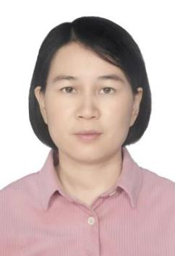
周华香 | 43052419****084822 | 20241109 | J0001196
徐爱玉 | 37083219****037345 | 20241114 | J0006716
沈阳 | 42088119****3071711 | 20241225 | J0001896
杨大慈 | 44050819****132611 | 20250110 | J0001856 | 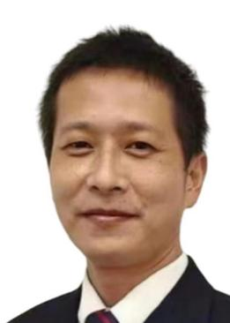
陈依如 | 33010219****111223 | 20250205 | J0003954
刘治文 | 13032119****077350 | 20250206 | J0002657
王茹 | 15282719****204824 | 20250227 | J0001854
陈韶润 | 44090219****183610 | 20250306 | J0004196 | 