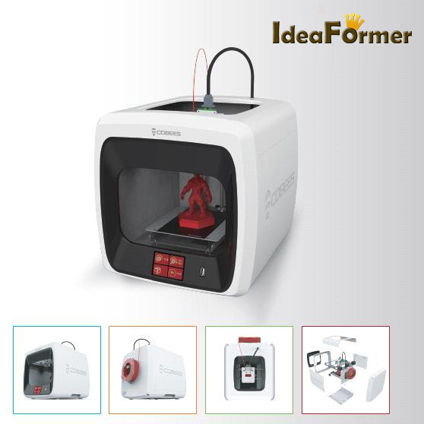

COBEES Ⅲ USER MENUAL

Contents

- Introduce

- Safety Precautions

- Precautions for Use

- Name of each component

- Preparing your device for installation and printing

- Using the printer

- How to use the printer - Mounting the filament

- Printing a Test Model

- Maintaining the printer

- Mechanical troubleshooting

- Specifications

✔Be sure to read the safety precautions before use.
✔This document is a general user's guide. The product is subject to change without notice
for improvement.
✔we shall not be liable for errors contained herein or for any damages arising out of or in connection with the furnishing or use of this document.

1. Introduce

Thank you for purchasing COBEES III.
Among various 3D printers, COBEES Ⅲ is a FDM type 3D printer, which is a low cost 3D printer which is easy to use and low maintenance cost in comparison with general FDM type 3D printers.

[Key Features of COBEES III]

- Case is made of plastic material and has excellent texture.
- Uses a proprietary mechanical system to reduce noise and improve print quality.
- It is very easy to use by applying the developed TOUCH LCD.
- Eliminated the difficulties of using open source programs using own slicing software.
- It is possible to print without special adhesive or taping which is commonly used with special coated coating and it is easy to take out the print after printing.

This User Manual explains the entire process from installation to sample model print step by step. If you are new to 3D printing and have used the 3D printer's unique technology and have used a lot of 3D printers to adapt it, please read the user's manual.

Experience new 3D printing with COBEES.

2. Safety Precautions

Before using the printer, be sure to read the "Safety Precautions" and follow the instructions.
These instructions are intended to prevent injury to the user or third parties and damage to the printer.
Failure to follow these instructions could result in serious injury or printer damage.
✔Because the printer generates high heat during operation, there is a risk
of burns if you put a human body or equipment inside during operation. If you put a human body or equipment inside, be sure to cool down after operation.
✔The printer uses moving parts such as motors, belts, and gears. If a
human body or other equipment is inserted into the unit during operation, there is a risk of injury from being caught by the unit.

✔Water or other liquids, metal chips, or other conductive objects may enter the printer, causing fire or shock. Also, do not operate with wet hands as it may cause fire / electric shock.
✔Do not turn off the power while the heating bed or the extruder is heated. The cooling fan does not turn, which could cause equipment failure or fire due to high temperature.
Install the printer in a well-ventilated place, because the printer will melt the material and smell it.
✔Do not disassemble or modify the printer in any way other than those approved by the user's manual.
Failure to do so may result in injury or damage to the printer, and any problems occurring in this case will be excluded from the gratuitous AS.

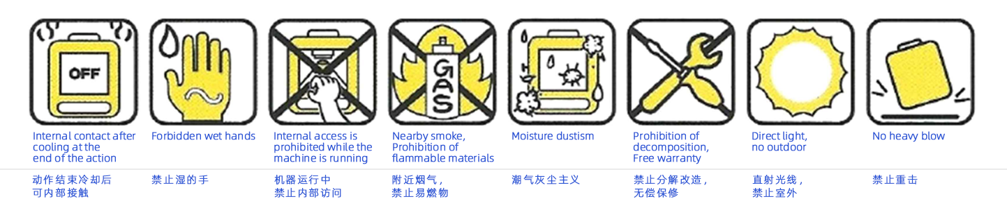

3. Precautions for Use
Be sure to read and follow the "Precautions for Use" before using the printer.

Filament | We use genuine filament sold.  *Failure to use non-genuine filament will be excluded from free AS.
Opened filament should be used as soon as possible.
Keep the filament firmly fixed on the spool so that it will not loosen when unavoidably stored.
Filament Change Loading Unloading | Note the extruder temperature setting.  *If the temperature setting is wrong, extruder trouble will occur due to nozzle clogging, filament shattering.
 | Set temperature when replacing new filament Caution and sufficiently remove old filament inside nozzle.
extruder (nozzle)  Of the heating bed Temperature condition | Extruder (Nozzle) / heating bed heated to the temperature suitable for the filament to be used
If the temperature of the filament is not within the proper
temperature range, poor quality of print such as filament carbonization, poor discharge, cracking, flooding, and equipment failure may occur.
 | After the print is completed, the sculpture is removed after the heating bed has cooled sufficiently.
Cleaning the nozzle | Regular discharge status check, cleaning and management  need.  * Replacement of wear nozzle due to normal use is not eligible for free AS.
Fixed Extruder | Regular fixation, extruder cleaning and other management needs
Cleaning of heating bed | Typical cleaning involves scraping surface contaminants  with a dry cotton cloth.  * Replacement of heating bed with coating damaged by normal use is not eligible for free AS.
Preparing AS Request | Record files and situations, printer inside, LCD display, etc. as a picture / movie when an abnormal condition occurs

- Name of each component

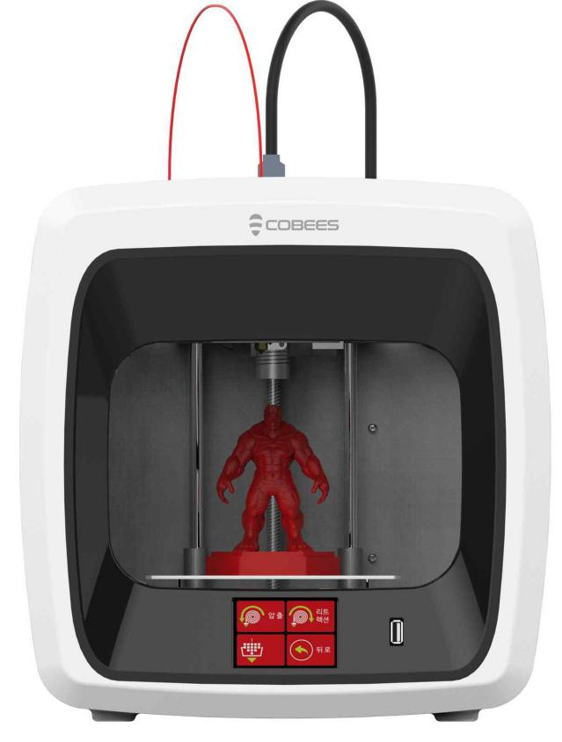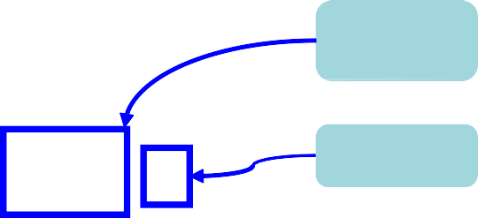
LCD
Screen
UCB port
Front side

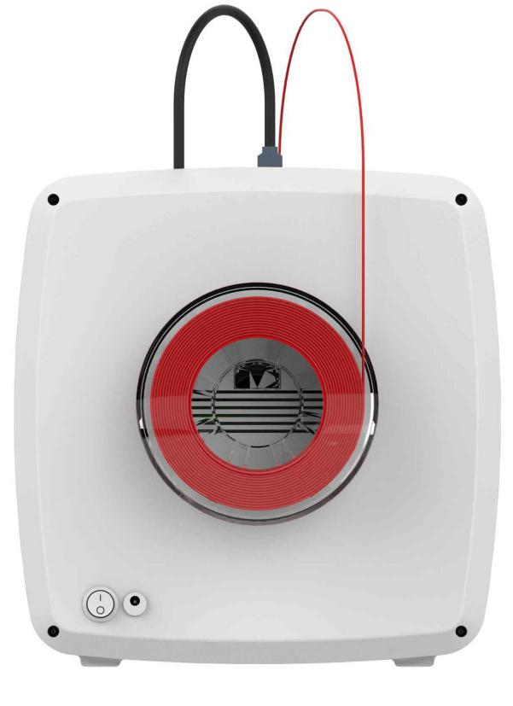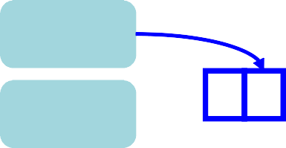
filament
holder
Power
Connector
Power button
Rear side

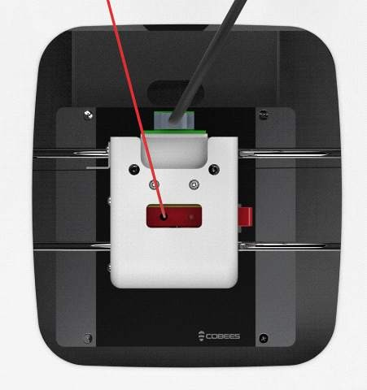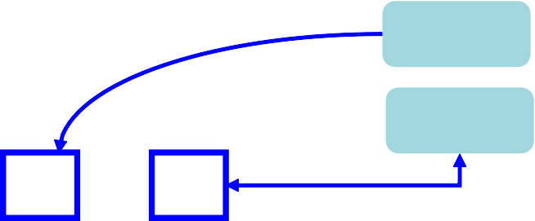
Filament
inlet

Nozzle handle

✔COBEES will check the print status of our head office laboratory before packing and shipping. There may be traces of use on heating beds, nozzles, etc. when opening / unpacking, You can use it with confidence because it is dead.

- Preparing your device for installation and printing
  - Before turning on the power of the printer, check again to make sure that all the packaging materials inside the printer have been removed, that the parts are not damaged, and that the spool mounting / rotation direction / rotation status is normal.

①Make sure that the switch on the back of the main unit is turned off.
② Connect the power adapter to the
cable, then plug the cable into an electrical outlet and connect it to the printer.

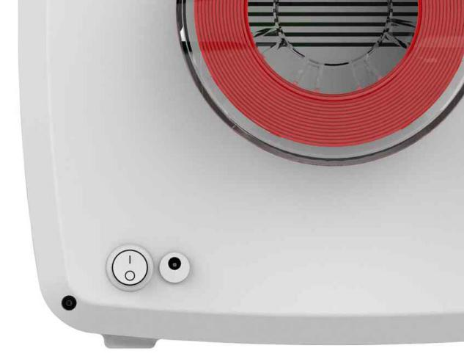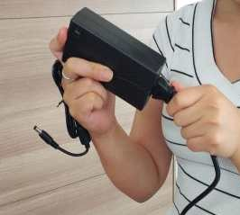

③ Turn on the switch on the back of the unit. ④ Check the LCD for proper booting.

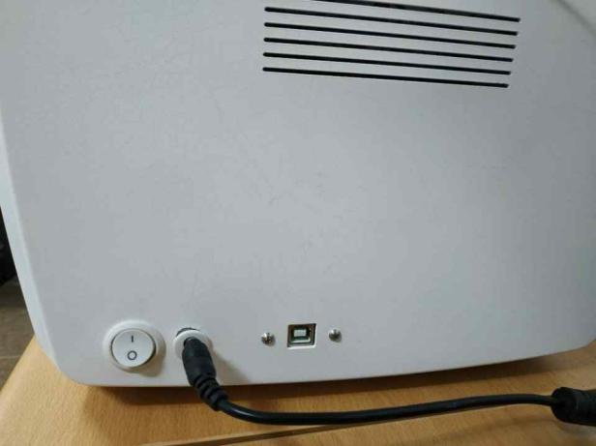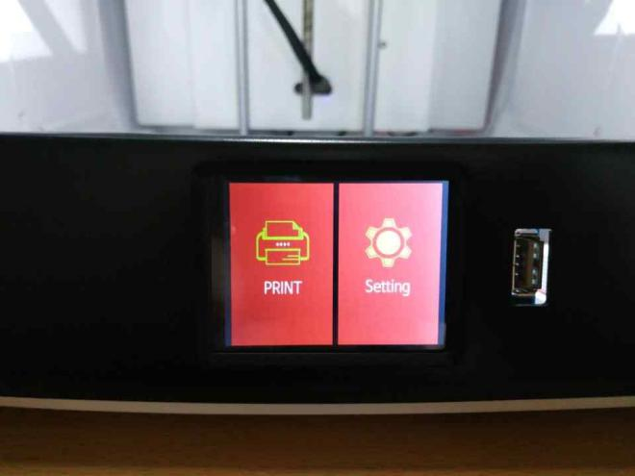

When disconnecting the power or communication cable, do not pull on the cable, but pull out the connector.
  - The communication card cable is connected to the PC and used to print directly to the PC or to update the firmware of the printer. It is not necessary to connect the communication cable where the installation place of the printer is not always connected with the PC.

- Using the printer
6-1. LCD Main

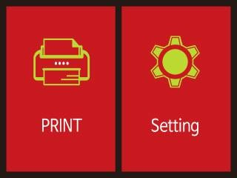

[1] | PRINT | This | button | is | for 3D printer print.
[2] | Setting | This | button | is | used | to | change | the | setting.

6-1-1. PRINT

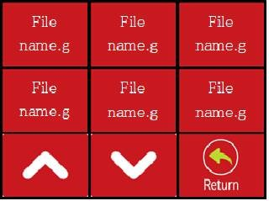

[3] | File name.g | This | button | is | used | to | display | the name of the file | to be print.
[4] | ︽ | This | button | is | used | to | move | to the next print file | page.
[5] | ︾ | This | button | is | used | to | move | to the previous print | file page.
[6] | Return | This | button | is | used | to | return | to the main screen.

6-1-2. Printing

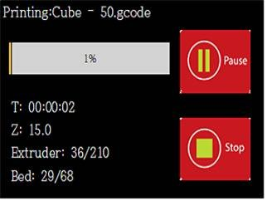

[7] Printing: |  | The | print file | name | and part of the | print | progress.
[8] Pause |  | This | button is | used | to pause print.
[9] Stop |  | This | button is | used | to stop print.
[10] T, Z, E, | B | print time, Z position, nozzle temperature, bad temperature.

6-2. Setting

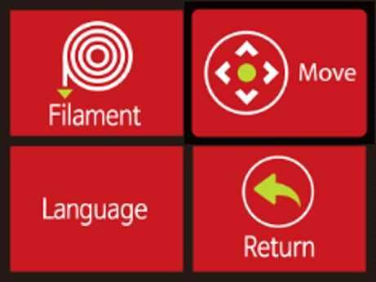

[11] | Filament | This | button | is | used | to | insert | and | remove filaments.
[12] | Move | This button goes to the leveling adjustment screen.
[13] | Language | This | button | is | used | to | select | the | language.
[14] | Return | This | button | is | used | to | return | to | the main screen.

6-2-1. Filament

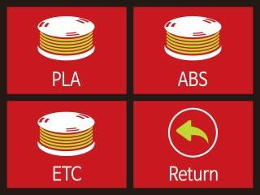

[15] | PLA | This | button | is | used | when using | PLA.
[16] | ABS | This | button | is | used | when using | ABS.
[17] | ETC | This | button | is | used | when using | ETC.
[18] | Return | This | button | is | used | to return to | the | setting | screen.

6-2-1-1. Filament in&out

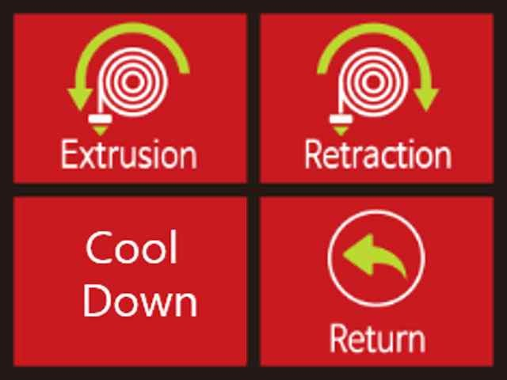

[19] | Extrusion | This | button | is | used | to | insert filaments
[20] | Retraction | This | button | is | used | to | remove the filament
[21] | Cool Down | This | button | is | used | to | cool the nozzle.
[22] | Retrun | This | button | is | used | to | return to the filament | screen.

6-2-2. Move ( Adjust level )
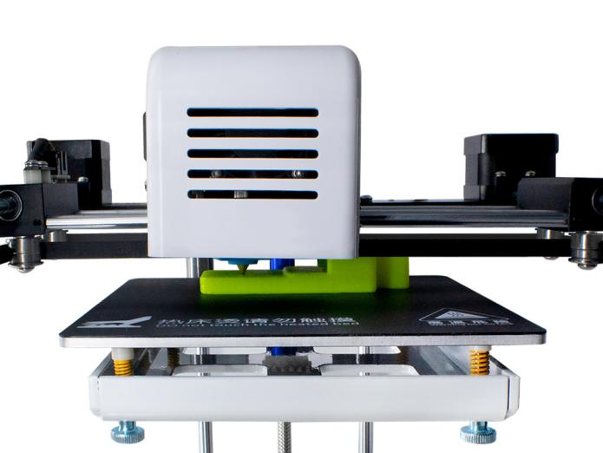

Note: the Yellow parts we call “ JPG” , It use for keep nozzle position is lower than the senser .

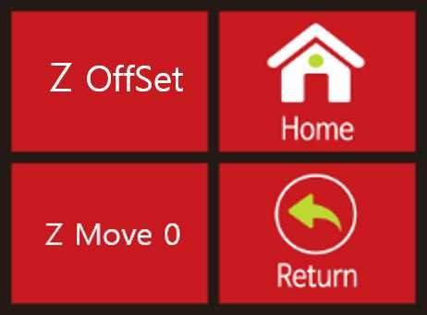

[23] | Z OffSet |  | This  and | button  bad. | is | used | to | adjust the distance between the | nozzle
[24] | Home |  | This | button | is | used | to | send the X, Y, Z axis to origin.
[25] | Z Move | 0 | This | button | is | used | to | move the Z axis position to 0.
[26] | Return |  | This | button | is | used | to | return to the setting screen.

Note : For bed level with nozzle , we already finished adjusted , Customer can use directly .

( Z move to 0, the nozzle and platform gap is 0, that mean it can printing now, if the gap is too big, you can adjust “-” , if the platform and nozzle is too tight , you can adjust “+” .

6-2-2-1. Z Offset

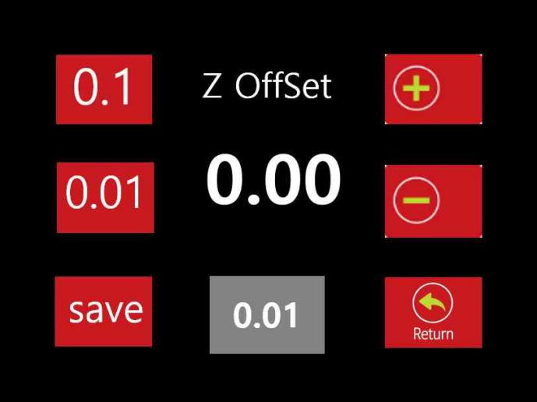

[27] 0.1 Buton | This button is used to adjust Z offset value in 0.1 unit.
[28] 0.01 Buton | This button is used to adjust Z offset value in 0.1 unit.
[29] Save Buton | This button is used to store the changed Z offset value.
[30] +Buton | This button is used to add up to the set value.
[31] -Buton | This button is used to subtract the set value.
[32] Return | This button is used to return to the axis movement screen.
[33] 0.00 Screen | The current Z offset value.
[34] Gray Screen | The part that represents the unit of change

Note : Z offset , “+” push this button, the heat bed with nozzle distance is bigger ; “-”push this button, the heat bed with nozzle distance is smaller.

6-2-3. StudioK （slice software）

The software in USB, you can open it .
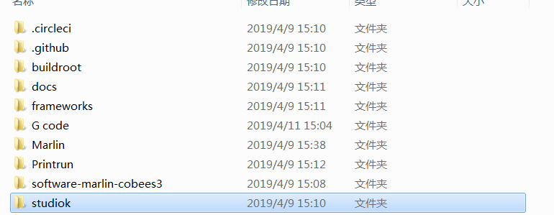

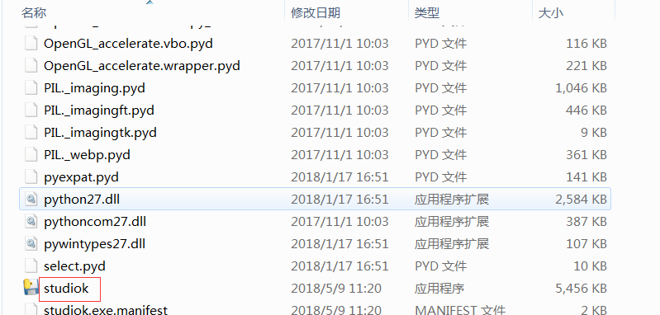

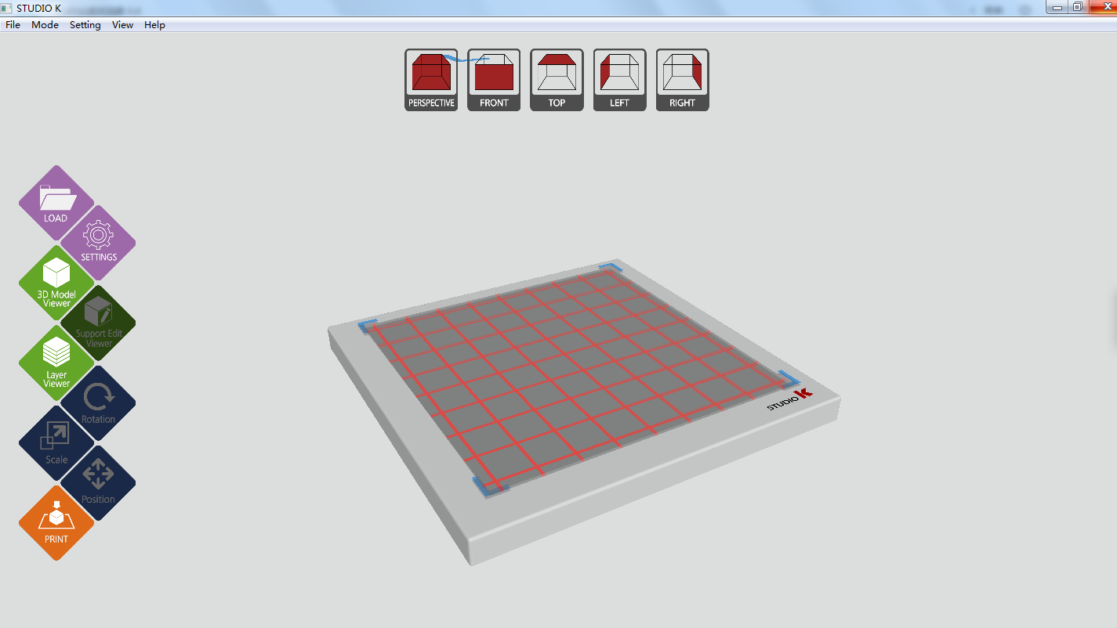

- How to use the printer - Mounting the filament

① Cut filaments in a diagonal pattern and straighten them. (About 3cm)

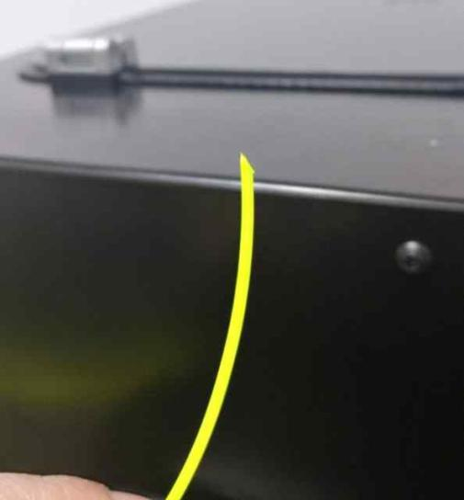

② Insert the filament into the rear hole part. Insert the nozzle long enough to allow it to escape to the Teflon tube connected to the nozzle.

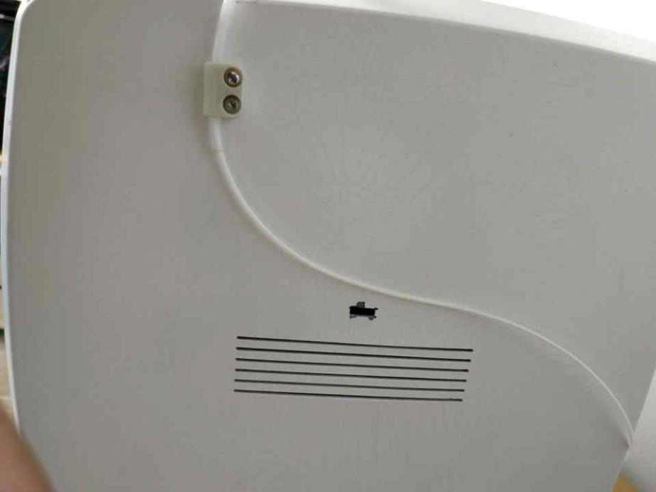

7-2. Mounting the filament

③ ress the push button on the nozzle and push the filament down as shown below. Plug the teflon tube slightly into the insert.

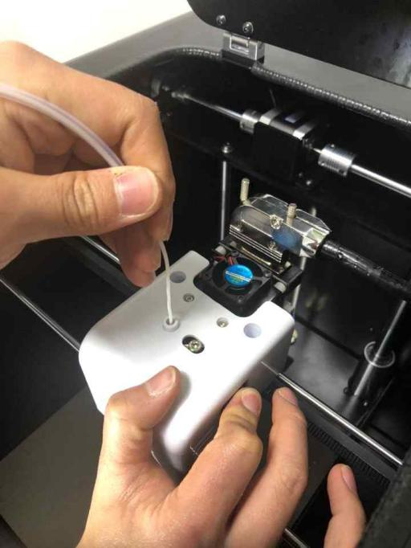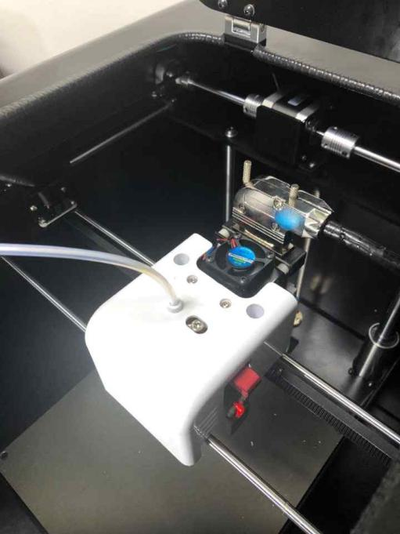
Teflon tube
attached
Push
button

④ In order of numbers on the main screen.

7-3. Filament Loading

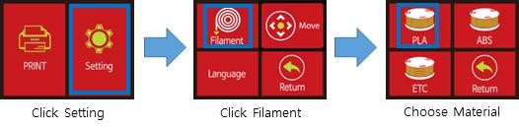

7-4. Filament UnLoad

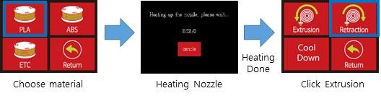

Filament Load, Unload For more information, please refer to the video on the last page.

7-5. Z Offset value change

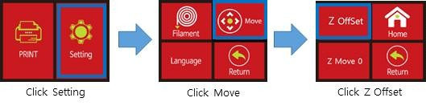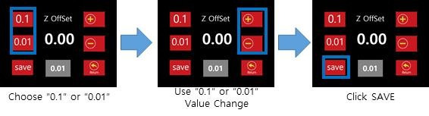

Please refer to the video on the last page for a detailed explanation of Z offset value change.

- Printing a Test Model

This is a description of the printer up to the actual print using USB memory. (USB plug in after printer turn on)

8-1. Confirm filament nozzle insertion before first print
Make sure that the filament is correctly inserted into the nozzle as shown below.

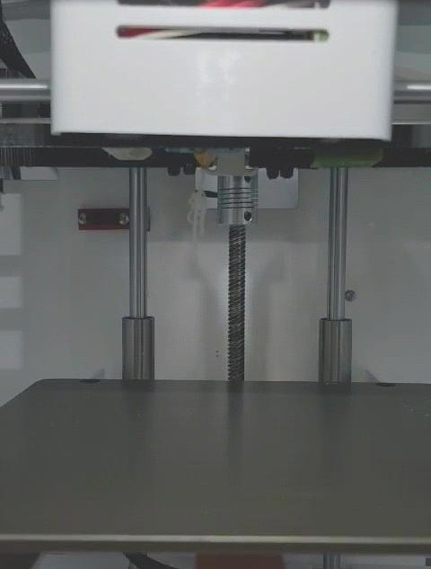

8-2. Test Print

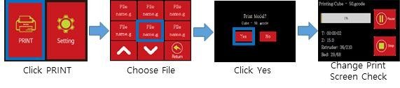

Maintaining the printer

*We used a special coated badm to reduce the difficulty of level adjustment and to increase the deposition rate. (Please be careful that the nozzle does not touch the badm.)

9-1. Nozzle management
The nozzle is located at the bottom of the extruder and is the component that melts the filaments and makes the sculptures.
If the nozzle is used as a printer consumable for a long time, it should be replaced with normal wear, impurities of filament carbonized residue and filament. However, if
proper management can not be done, problems will occur earlier than the proper lifetime and the print condition will be poor. Please clean the nozzles regularly in order to use the nozzle with a uniform print quality.

9-2. Clean contaminants on the filament path
It is not recommended to use all of the basically supplied materials in combination with an extruder that can be used. Filaments have a characteristic difference in temperature and temperature, and this does not occur immediately, but the problem that occurs gradually is more severe than expected. Using PLA If you use ABS, no matter how you think you removed the inner filament, PLA remains on the wall. These filament residues will accumulate continuously and will eventually clog the nozzles and cause print failures

9-3.Cleaning the inside of the nozzle
Cleaning of the space between the inlet and the nozzle is basically possible by filament loading. If the inside of the filament is deformed due to the mixed use of materials and loading can not proceed, please clean the inside with a nozzle cleaning pin.

9-4. Heating Bed Management
The heating bed is the floor where the print is formed as the filament melts and discharges. It is easy to be contaminated with melted filaments and filament pieces when molding, and if the print is continued in a polluted state, contaminants stick to the printed molding, which will contaminate the molding or prevent the molding from sticking to the heating bed during printing.
Before and after molding, the heating bed should be kept in a clean condition to prevent the printout from becoming defective by contaminants.
① Remove filament residue from heating bed using tweezers, scraper, brush or other tools. When using a tool, be careful not to damage the surface of the heating bed.
If the surface is damaged, the coating will peel off and the print will not stick well.

Messy heating bed | Cleaned heating bed
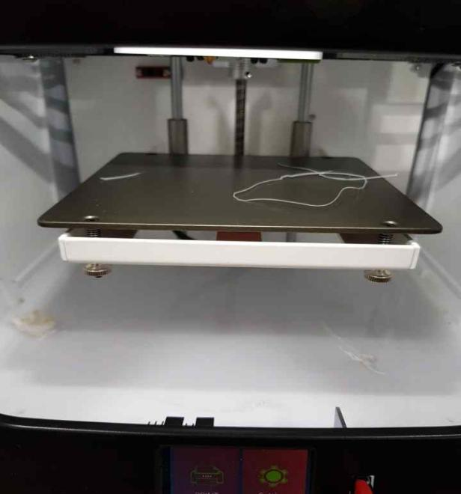  The top and surrounding debris on the heating bed is removed using tools (tweezers, scrapers, brushes, air sprayers, vacuum cleaners) | 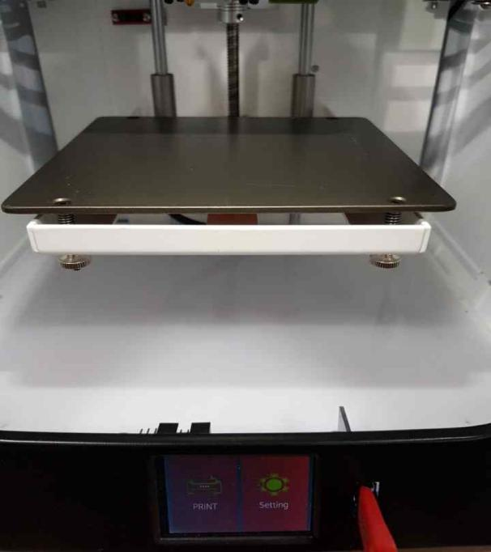
- The surface of the heating bed may appear blotchy, but this occurs during the coating
process and is not related to heating bed properties.
- The coating life of the heating bed depends on the user's printing habits. If the printout falls too easily, replace the heating bed.
In the case of an print method in which filament is melted and print, the molten filament
hardens and shrinks, which may cause lifting from the bottom of the print. It can be improved by print temperature condition, adhesion of heating bed, or slicing option change, but it is mostly a phenomenon that varies depending on degree of shrinkage. Consider a design method that can dissipate the contractive force when designing 3D models.
- In the case of some wet tissues, do not use wet tissues because the cleaning component
will contaminate the heating bed coating.
- Do not remove the heating bed or apply excessive force to remove the sculpture. It may cause malfunction due to shock.

Mechanical troubleshooting

* print quality may vary greatly depending on the model depending on the print condition or
the option settings such as cura- tion at the time of G-code generation. Therefore, check the quality by using various print conditions or options.
If there is a problem with the equipment, it is important to clearly identify the problem.
Please take photographs of modeling files, G-code files, photos of problems, and videos so that you can refer to them for customer support.

- When the data on the USB memory can not be seen
→ COBEES supports Korean, English, and numeric file names. However, if the name is too long, please note that the characters may be broken or appear blank. (The name appears on the screen during printing.)

→ File name ". "If you insert a comma, the print will not work. (Recognized as an extension after ".")

→ COBEES LCD screen shows only files with extension .gcode. Check if the file has been copied properly in the SD card memory.

- When the USB memory data is not being print
→ print Check that the selected file has the extension G-Code. COBEES can use only sliced G-Code files using a slicing program

→ The data on the USB memory may be damaged. Please recreate the G-Code file.

→ The 3D model may be incorrect and there may have been a problem loading the slices. Open the original 3D model in a slicing program to check if the slicing problem or G-code conversion is normal, and use a separate 3D model checking program to check whether the 3D model is abnormal.

→ There may be a problem saving data to USB memory due to security program or virus. Please check and take action and try again.

- When the filament is not discharged to the nozzle
→ Make sure it is a genuine filament. Some filaments have a different temperature condition than regular filaments, or are subject to severe thermal deformation when used with COBEES, which can cause problems with extrusion, which can cause the extruder to fail. Printer failure due to non-genuine filament use is excluded from free AS.

→ Check that the filament supply is smooth. If there are problems such as twisting filaments in the spool or loosening the filaments, arrange the filaments. It is recommended that once twisted or unwound filaments cause permanent problems, they
should be discarded.

→ Filaments contaminated with environment such as moisture and dust may differ in characteristics from the initial opening. The use of these filaments can cause malfunctions such as extruder clogging. Use the opened filament as soon as possible. If it is necessary to store the filament, keep it on the spool so that it will not loosen. Use vinyl or the like to keep moisture / dust out and keep it for a short time.

→ Make sure that the thickness of the supplied filament is not too thick or thin. COBEES should only use filaments with a diameter of 1.75 mm for accurate supply of filaments. When using thinner or thicker filaments, the filament may get caught in the equipment or cause the equipment to fail.

→ Make sure that the extruder temperature conditions of the filament and the printer are correct.

→ If the nozzle is damaged, replace the nozzle. The nozzle is a consumable. Replace with designated AS.

- When the sculpture is stuck without attaching to the floor (heating bed).
→ Make sure it is a genuine filament. Some filaments are not adhered to our heating bed, which can cause equipment failure when printting.

→ Filaments contaminated with environment such as moisture and dust may differ in characteristics from the initial opening. Adhesion to the heating bed may be poor when using such filaments. Opened filaments should be used as soon as they are used. If necessary, store the filaments on a spool so that they will not loosen. Use vinyl or the like to store moisture or dust for a short period of time.

→ Remove contaminants from the heating bed. Wet tissues sold on the market can damage the heating bed coating depending on the type.

→ Make sure that the temperature conditions of the filament, heating bed and extruder are appropriate. The heating bed of COBEES must be in accordance with the filament and temperature conditions, and the ionic strength may vary depending on the type of filament, model and print environment.

→ Make sure that the area attached to the heating bed is too small or the molding floor is irregular. You can improve by using the Floor Auxiliary option when creating a G-Code or slowing down the first layer print.

→ Check that the coating on the heating bed is damaged or that the heating bed is bent excessively. In this case, the heating bed should be replaced. Evaporating film for heating bed is a consumable. Please use the designated AS point.

- Part of the sculpture, mainly when the floor rim falls off the floor.
→ When creating G-Code, you can improve some by option setting such as inner fill density.

→ This is caused by the shrinkage of the material in the printer using the heat melting method.
Adjust the print conditions (extruder, heating bed, printer internal temperature) or use materials with less shrinkage. However, shrinkage can be improved slightly depending on the material, but it is the natural phenomenon that occurs when the molten filament
solidifies, and modifying the model to improve the shrinkage is the most effective suppression method.

- When the sculpture does not fall from the floor (heating bed).
→ Please wait until the heating bed has cooled sufficiently. Forcibly releasing will damage the heating bed. The COBEES heating bed has a sculpture attached to the floor during molding, and the sculpture falls easily when the heating bed cools down after the molding is completed. The temperature at which the moldings fall depends on the filament and molding model used and the surrounding environment.

→ After the heating bed is sufficiently cooled (at room temperature), if the sculpture does not fall, push the flat end of the object into the bottom of the sculpture and remove it.

→ If the scum remains on the heating bed, the scum may stick to the fixed scum and not fall off the bed. Keep the surface of the heating bed clean.

→ If the coating on the heating bed is damaged, the deposited film must be replaced. The deposited film can be purchased from the exclusive Cobis mall.

- When the print is completed, but only a part of the molding is printed, and the print is not made at all or the print is strange.

→ Check the print model and G-Code. If the model is abnormal, there may be a problem in creating G-Code. Please correct the model and retry.
→ Depending on the model or on the support stand, interference with the sculpture of
the part already printed and the support may cause problems with the print. Changing the slicing method (such as adjusting slicing options or changing direction) can be improved.

→ Remove contaminants inside the nozzle.

→ If there is no abnormality in the model and the problem persists, it is necessary to replace the nozzle, such as AS. Please use designated AS point.

- When the job is interrupted while printing.
→ Check power supply.
→ IIf the problem occurs continuously, record the problem occurrence as a picture or video and use the designated AS point.

Operation description Video collection https://www.youtube.com/channel/UCNhlyRFM463oqfEz8rbDNgA

Filament insertion (PLA Load)
https://www.youtube.com/watch?v=IdPfYRA2HqM

Filament remove (PLA Unload)
https://www.youtube.com/watch?v=UEAwSoML-Vg

Printing a file
https://www.youtube.com/watch?v=nG8plAOuNkA

Nozzle Cleaning
https://www.youtube.com/watch?v=k0nbAw8olcc

Nozzle disassembly
https://www.youtube.com/watch?v=i6gI_DF7Z5c

Nozzle Assemble
https://www.youtube.com/watch?v=y3WStUBBo40

Z Offset value change

- Specifications

standard
Product Size | 340x315x320 mm
Product weight | 6kg
Packing box | 460x420x450 mm
Package weight (including main unit and accessory accessories) | 8kg
Temperature
Ambient operating temperature | 10 - 40 °C
Electricity
AC input | Free Volt 100~240V, 50~60Hz, 5A
Power Supply) | 24V DC @ 6.5A
Power consumption | 160W (MAX)
Memory and communication environment | USB
software
Slicing software | Studio K, Ultimaker Cura, Simplify3D (for Windows)
Use design file type | STL model file
Supported Operating Systems | Windows xp or More than
Printing
Printing technology | FFF (Fused Filament Fabrication)、FDM
Screen | TFT Touch Screen
Print method | USB 、 connect to computer
Molding size | Max : 120x120x120mm
Molding speed | 20mm/sec ~ 150mm/sec
Filament diameter | 1.75mm
Filament type | PLA, ect
Nozzle diameter | 0.4mm
Nozzle maximum temperature | 0-230°C normally , 247°C max
Heating Bed Maximum Temperature | 70°C
- This specification is subject to change without notice.

Company Information

Address: Second floor,Buliding 1,zaobei dongshan industrial area,zaobei road,zhuhai,china
Email : ricohaa@bell-ideaformer.com (CEO)
james-salesdepartment@bell-ideaformer.com ( Manager)

