Banner
- 更换背景图片

Designed for static pressure pile project, SinoGNSS high-precision piling solution is an easy-to-use piling system that able to deliver centimeter-level piling positioning accuracy for multiple construction applications. It largely boosts eld productivity and reduces rework compared to traditional leveling method.

- 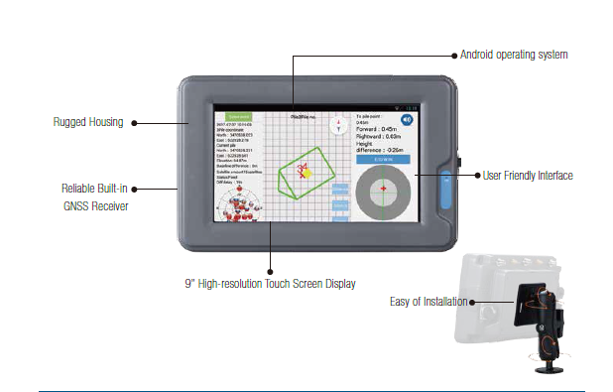
- 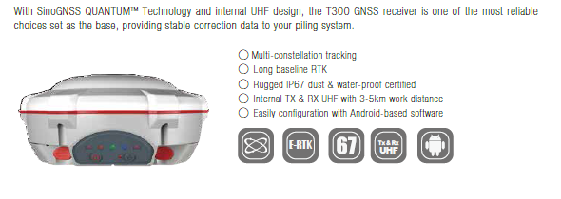
- 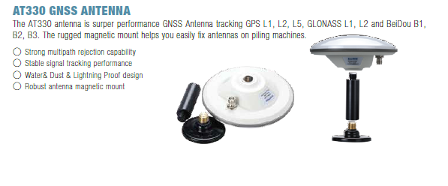
- 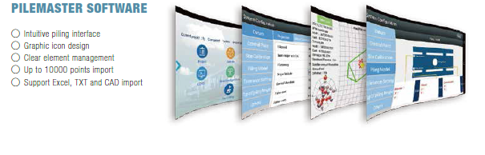
Application industry
Machine control
Related product
T300, Piling tablet，K728，AT340
Documents
SinoGNSS Professional Positioning Solution-DS-ENG Datasheet
High-accuracy piling system used in Maldives Case study

