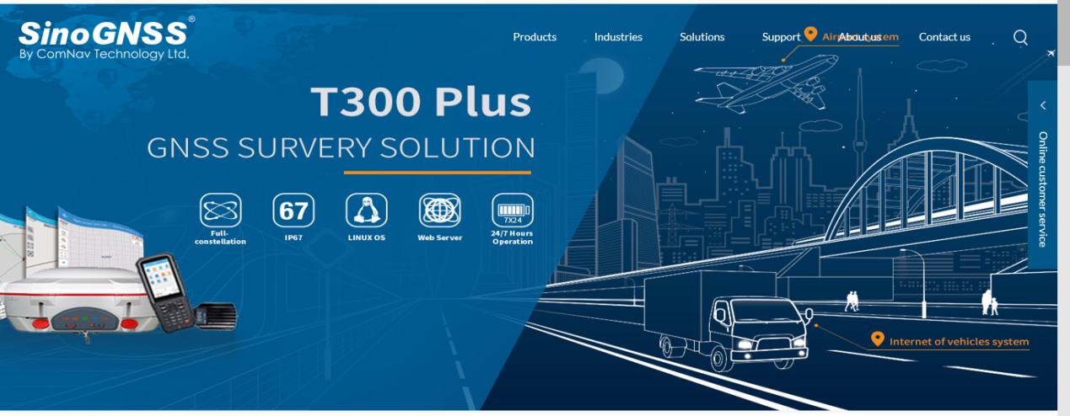
替换成G100/200的banner，以及下面，都替换成G100/G200Solution里的内容

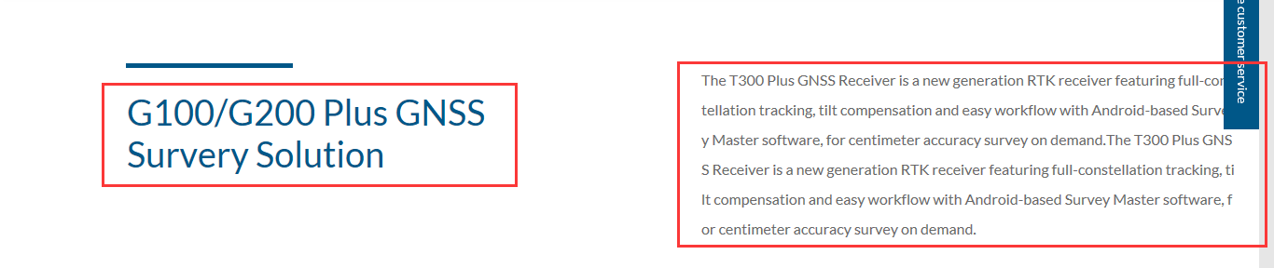
替换成：
G100/G200 GIS Solution
The G100/G200 is a rugged, compact, wearable GNSS receiver that provides professional-level positioning data to any connected mobile device with AndroidTM and WindowsTM Mobile operating system. Integrating an antenna and the high-performance SinoGNSS OEM board inside, the G100 receiver delivers sub-meter accuracy positioning for your GIS applications. With SinoGNSS AT-series GNSS antenna, the G200 is able to deliver centimeter positioning accuracy for multiple land survey tasks.

Application Industry
替换成
Land Surveying
Machine Control

Related Products
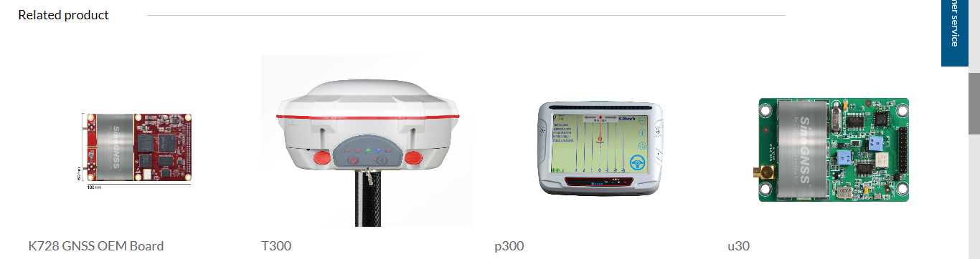
替换：
T300
T30
T300 Plus
R500

Documents
SinoGNSS G100G200 GIS Solution-DS-ENG.pdf Release Date: 2018-02-12 Version: 1.0

